APPENDIX V TO D.T2.1.1.

DIGITAL MATURITY ASSESSMENT (DMA)

This document represent a supplementary part (Annex) of the Appendix to this integral delivery of the D.T2.1.1 Training process Circular 4.0 - Capacity building manual and toolkit and represents one of the tools deployed in the Training process at which aims the Operators Training Course.

Questionnaires of the DMA tools
In the following subsection, the complete question sets of the Digital Assessment Tools are represented. Note that not all of the Tools were publicly available and therefore their methodology could not be overviewed.

Digital Maturity Model
- Transformed Strategy
(A) Wie gut ist Ihre Digital-Strategie dokumentiert und kommuniziert?
(B) Wie weit erstreckt sich die Entwicklung und Umsetzung der Digital-Strategie im Unternehmen?
(C) Welchen Einfluss hat Ihre Digital-Strategie auf das bestehende Betriebs-und Geschäftsmodell?
(D) Seit wann existiert die Digital-Strategie, und wie häufig wurde sie bereits aktualisiert?

- Transformed Leadership
(A) Wie stehen die Führungskräfte in Ihrem Unternehmen zur Umsetzung der Digital-Strategie? Wer ist mit der Strategieumsetzung beauftragt?
(B) Gibt es führende Funktionsbereiche bei der Umsetzung der Digital-Strategie?
(C) Wie würden Sie die Führungskultur in Ihrem Unternehmen beschreiben?
(D) Welchen Einfluss hat die Digital-Strategie auf das Aufgabenprofil Ihrer Führungskräfte? Gibt es spezielle Positionen wie z. B. CDO oder Digital Transformation Officer?

- Transformed Products
(A) Wie weit ist die Digitalisierung Ihres Produkt- und Dienstleistungsangebotes fortgeschritten? Welche digitalen Services bieten Sie bereits an? Welche besonderen Kundenvorteile werden dadurch erzeugt? Welche Wettbewerbsvorteile ergeben sich aktuell dadurch?
(B) In welchem Umfang werden durch die Digitalisierung neue Wertschöpfungsquellen erschlossen?
(C) Wie stark sind digitale Komponenten für die Erbringungen der Gesamtleistung erforderlich?
(D) Wieviel Prozent des Umsatzes erwirtschaften Sie mit digitalen Produkt und Dienstleistungsangeboten? Wie relevant sind digitale Zusatz-Services für die „offline“ Umsatzgenerierung?

- Transformed Operations
(A) Welche Ressourcen (Personal, Geld) stehen für die Umsetzung der Digital-Strategie zur Verfügung?
(B) Wie würden Sie die Qualität der funktionsübergreifenden Zusammenarbeit bezeichnen? Wie stark werden externe (Dienstleister o.ä.) in Geschäftsprozesse integriert (beispielsweise in Innovations-, Marketing-und Serviceprozesse)?
(C) Wie stark sind Digital-Aktivitäten in die Kernprozesse integriert?
(D) Inwiefern führen Impulse aus der Digital-Strategie zu Innovationen im Betriebsmodell, d.h. in den Geschäftsprozessen? Wie bewerten Sie den Innovationsgrad dieser Veränderung?
- Transformed Culture
(A) Wie transparent ist das Unternehmen für die Mitarbeiter, und wie offen werden strategische Themen mit Ihnen diskutiert? Wie sind die Mitarbeiter in den Dialog eingebunden? Wie wirkt sich die Digitalisierung auf die Transparenz aus?
(B) Wie schnell werden innerhalb des Unternehmens Entscheidungen getroffen? Wie stark sind Entscheidungsbefugnisse innerhalb des Unternehmens dezentralisiert? Welche konkreten Grenzen sind für Individualentscheidungen vorgegeben z. B. im Kundenkontakt? Welchen Einfluss hat die Digitalisierung auf die Entscheidungsgeschwindigkeit?
(C) Wie intensiv tauschen sich Mitarbeiter und Führungskräfte im Tagesgeschäft über das Unternehmen aus? Wie vernetzt ist die Kommunikation in der eigenen Organisation?
(D) Welche Rolle spielen digitale Medien für den Dialog? Wie stark ist der permanente Wandel Teil der Unternehmenskultur? Welche konkreten Ansätze und Methoden hat das Unternehmen für das Change Management etabliert?

- Transformed People
(A) Wer verfügt bei Ihnen im Unternehmen über eine besondere digitale Expertise? Wie viele dieser Experten gibt es? In welchen Funktionsbereichen?
(B) Welche Möglichkeiten der Weiterbildung zum digitalen Kompetenzaufbau bieten Sie den Mitarbeitern? Sind diese Angebote verpflichtend? Sind dies interne oder externe Weiterbildungsmaßnahmen?
(C) Welche Maßnahmen setzen Sie ein, um den digitalen Kompetenzaufbau zu stärken? Wie unterstützen Sie Teilbereiche bei der Umsetzung der Digital-Strategie? Gibt es bei Ihnen ausgewiesene Kompetenzzentren?
(D) Gibt es spezifische Stellenbeschreibungen oder einzelne Aufgabengebiete, die erst durch die digitale Strategie erzeugt wurden? Wie viele Stellen befassen sich ausschließlich mit digitalen Inhalten? In welchen Organisationsbereichen ist das der Fall?

- Transformed Governance
(A) Welche Leitlinien gibt es für den Umgang mit digitalen Medien? Wie klar sind diese beschrieben? Wie verbindlich sind die Leitlinien? Wie stark werden sie angewendet?
(B) Wie erfolgt die Steuerung der Digital-Aktivitäten? Welche Einheiten/Bereiche sind mit der Steuerung beauftragt? Wie funktioniert das Zusammenspiel zwischen Steuerung und dezentraler Umsetzung?
(C) Welche Metriken werden eingesetzt, um den Erfolg der Digitalstrategie zu messen? Wie wirken sich diese Metriken auf die wirtschaftlichen Zielgrößen aus? Wie erfolgt die Anbindung der Erfolgsmessung an das Strategie-Update?
(D) Wie gut ist die Digital-Strategie an die Unternehmensstrategie angebunden? Wie erfolgt die Vernetzung bei der Strategieentwicklung?

- Transformed Technology
(A) Welche Tools und Werkzeuge werden für die Analyse digitaler Inhalte genutzt? Wie sind die Daten aus dieser Analyse in Prozesse eingebunden? Wie beurteilen Sie Ihre Fähigkeiten, Kunden über verschiedene Kanäle hinweg konsistent und personalisiert zu betreuen? Inwieweit kann man damit die Unternehmens- und Prozesssteuerung im Tagesgeschäft unterstützen?
(B) Welche Tools werden intern für die Modellierung, Automatisierung und Steuerung von Geschäftsprozessen genutzt? Wie stark sind Prozesse bereits durch IT automatisiert?
(C) Wie umfassend sind Arbeitsplatzkonzepte bereits umgesetzt, die Mitarbeiter unterstützen – unabhängig von Zeit, Raum und Endgerät – ihre Aufgaben zu erledigen und effektiv zusammenzuarbeiten?
(D) Welche technischen Fähigkeiten haben Sie erworben, um die Entwicklung von digitalen Produkt- und Dienstleistungsangeboten zu unterstützen? Welche Fertigungsprozesse werden mittlerweile digital gesteuert?
Unmoderated Google Translation
- Transformed Strategy
(A) How well is your digital strategy documented and communicated?
(B) How far is the development and implementation of the digital strategy in the company?
(C) What influence does your digital strategy have on the existing operating and business model?
(D) How long has the digital strategy been in existence and how often has it been updated?
- Transformed leadership
(A) How are the executives in your company regarding the implementation of the digital strategy? Who is responsible for implementing the strategy?
(B) Are there leading functional areas in the implementation of the digital strategy?
(C) How would you describe the leadership culture in your company?
(D) What influence does the digital strategy have on the task profile of your managers? Are there special positions such as B. CDO or Digital Transformation Officer?
- Transformed Products
(A) How far has the digitization of your product and service offering progressed? What digital services do you already offer? What special customer benefits does this generate? What competitive advantages does this currently result in?
(B) To what extent will digitalization open up new sources of added value?
(C) How much are digital components required to deliver overall performance?
(D) What percentage of sales do you generate with digital products and services? How relevant are additional digital services for "offline" revenue generation?
- Transformed Operations
(A) Which resources (personnel, money) are available for the implementation of the digital strategy?
(B) How would you describe the quality of cross-functional cooperation? How much are external (service providers, etc.) integrated into business processes (e.g. in innovation, marketing and service processes)?
(C) How strongly are digital activities integrated in the core processes?
(D) To what extent do impulses from the digital strategy lead to innovations in the operating model, i.e. in business processes? How do you rate the degree of innovation of this change?
- Transformed Culture
(A) How transparent is the company for the employees and how open are strategic issues discussed with you? How are the employees involved in the dialogue? How does digitization affect transparency?
(B) How quickly are decisions made within the company? How strong are decision-making powers decentralized within the company? What are the specific limits for individual decisions? B. in customer contact? What influence does digitization have on the speed of decision-making?
(C) How intensively do employees and managers exchange information about the company in day-to-day business? How networked is the communication in your own organization?
(D) What role do digital media play in dialogue? How strong is permanent change part of the corporate culture? What specific approaches and methods has the company established for change management?
- Transformed People
(A) Who has special digital expertise in your company? How many of these experts are there? In which functional areas?
(B) What options for further training in digital competence building do you offer employees? Are these offers mandatory? Are these internal or external training measures?
(C) What measures are you taking to strengthen digital skills development? How do you support sub-areas in implementing the digital strategy? Do you have any competence centers that you have identified?
(D) Are there specific job descriptions or individual areas of responsibility that were only created by the digital strategy? How many jobs deal exclusively with digital content? In which organizational areas is this the case?
- Transformed governance
(A) What are the guidelines for dealing with digital media? How clearly are these described? How binding are the guidelines? How much are they used?
(B) How is digital activities managed? Which units / areas are responsible for the control? How does the interaction between control and decentralized implementation work?
(C) What metrics are used to measure the success of the digital strategy? How do these metrics affect the economic targets? How is the measurement of success linked to the strategy update?
(D) How well is the digital strategy linked to the corporate strategy? How is networking done in strategy development?
- Transformed Technology
(A) Which tools and tools are used for the analysis of digital content? How are the data from this analysis integrated into processes? How do you assess your ability to consistently and personally serve customers across different channels? To what extent can it support corporate and process control in day-to-day business?
(B) Which tools are used internally for the modeling, automation and control of business processes? How strong are processes already automated through IT?
(C) How comprehensive are workplace concepts already implemented that support employees - regardless of time, space and end device - to complete their tasks and work together effectively?
(D) What technical skills have you acquired to support the development of digital product and service offerings? Which manufacturing processes are now digitally controlled?

Self Check Industry 4.0
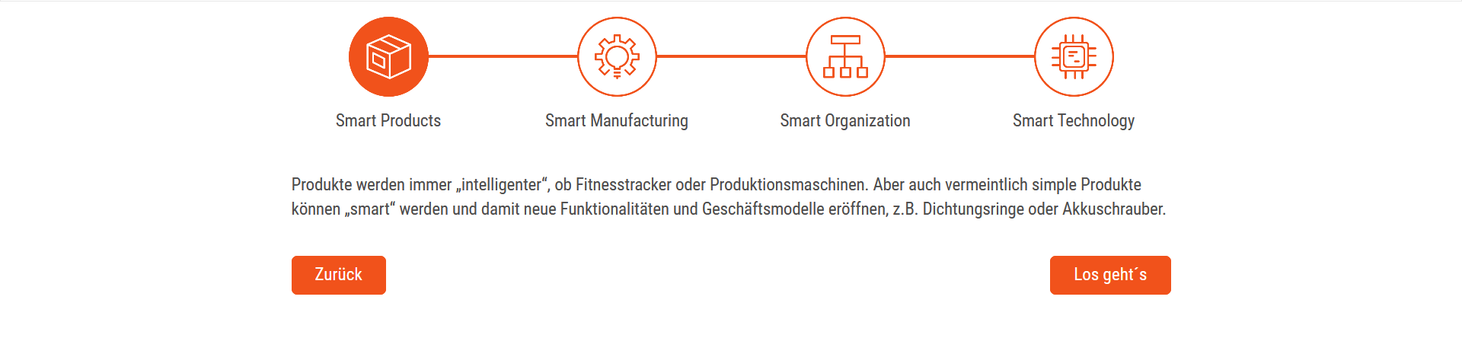
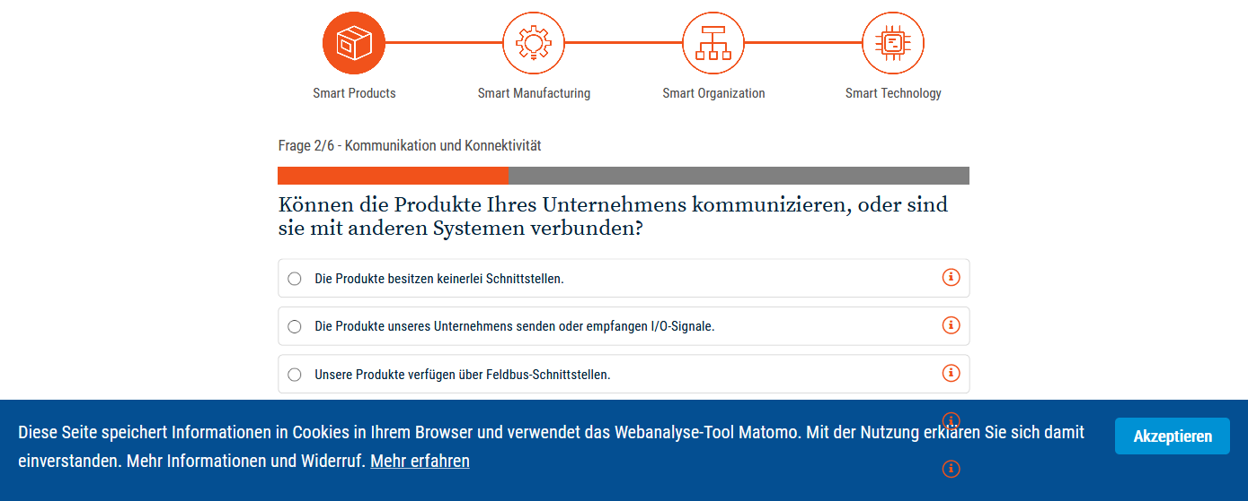

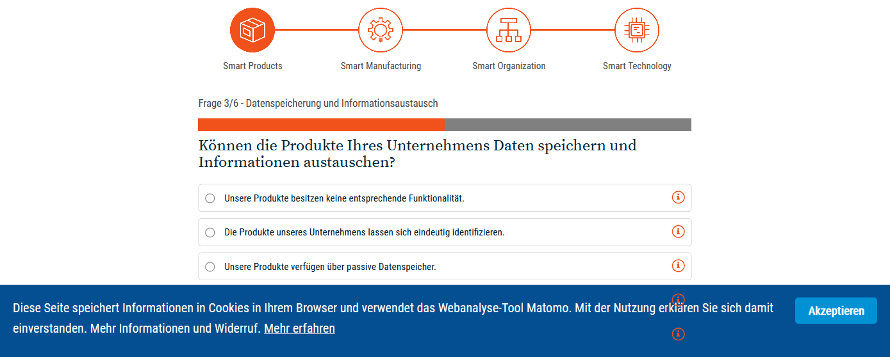
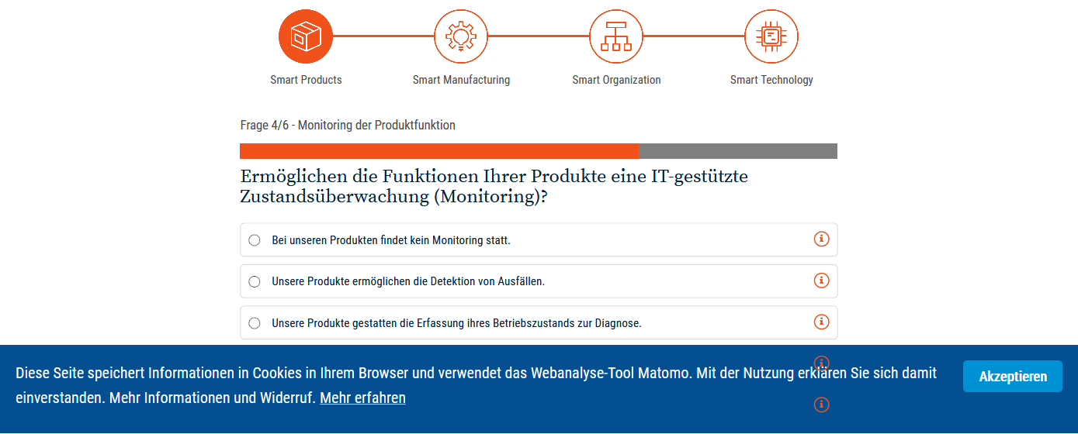
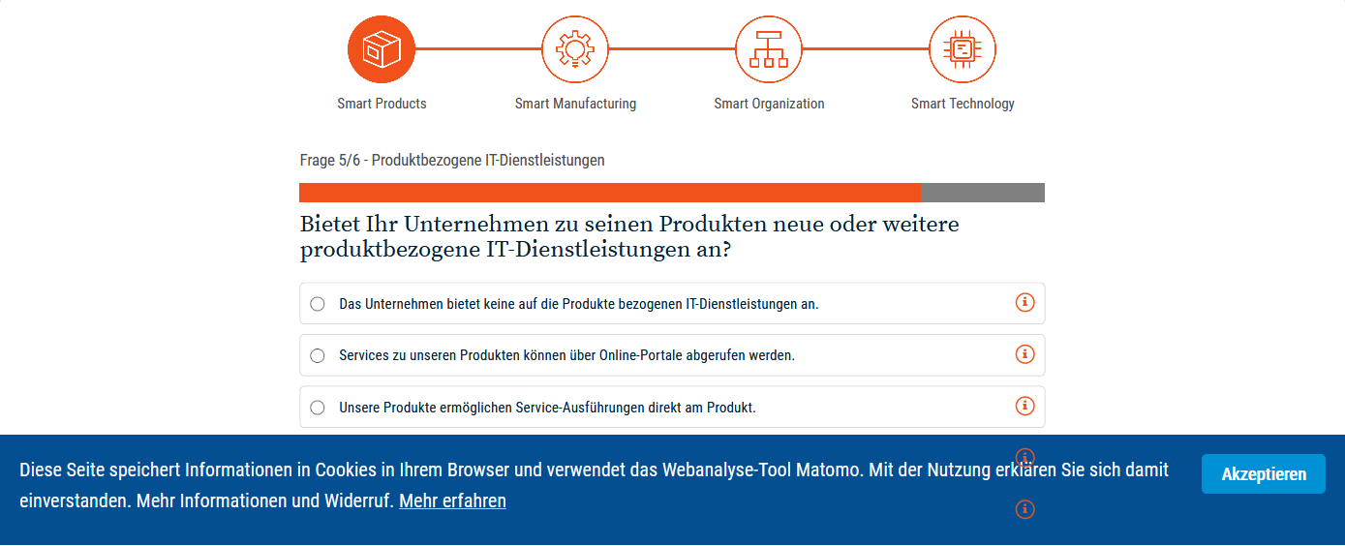
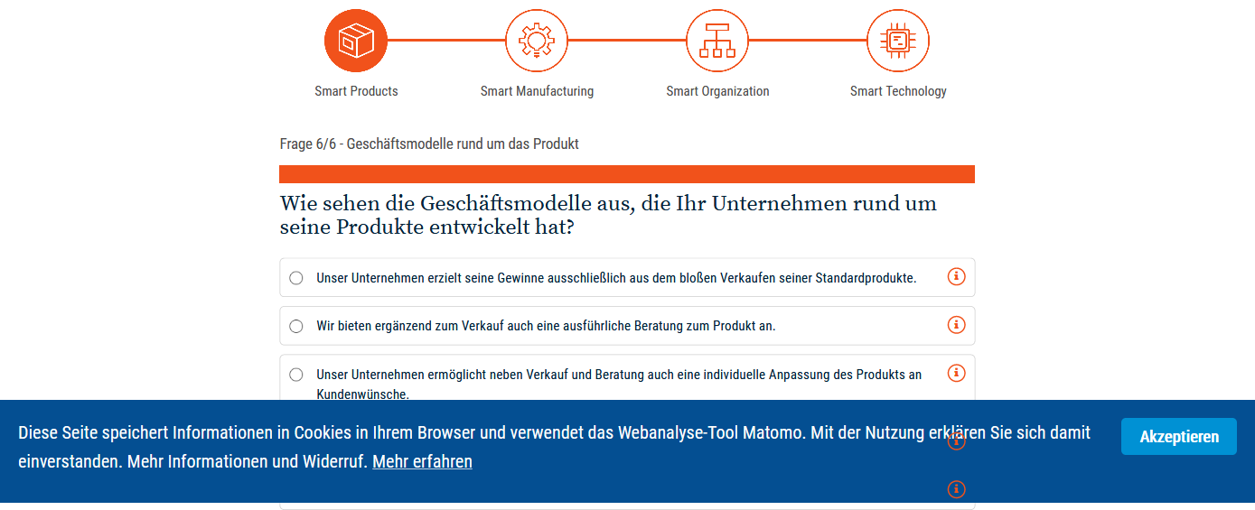
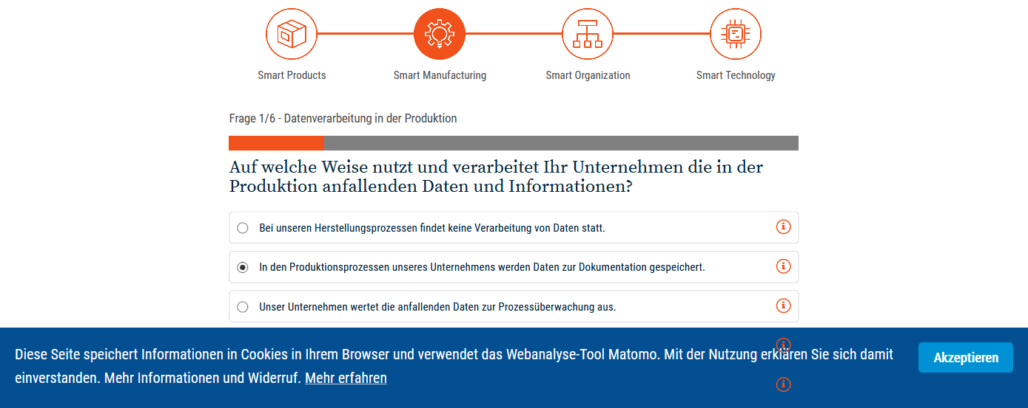
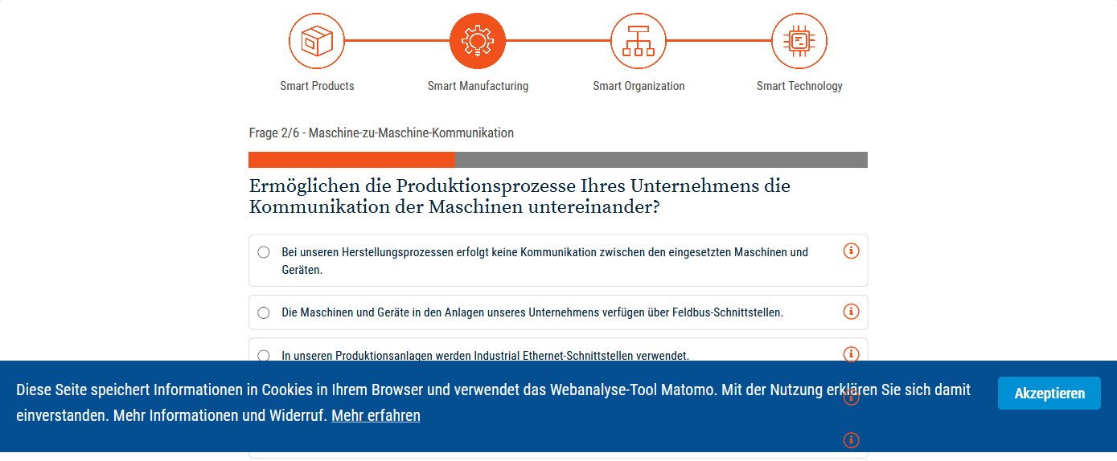

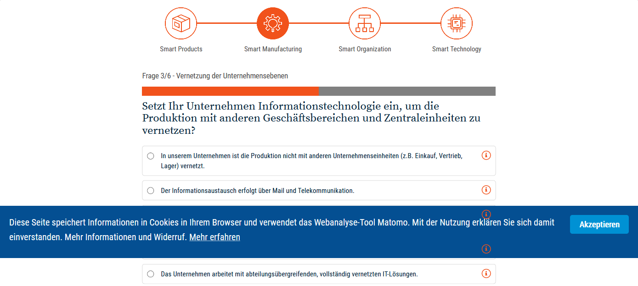
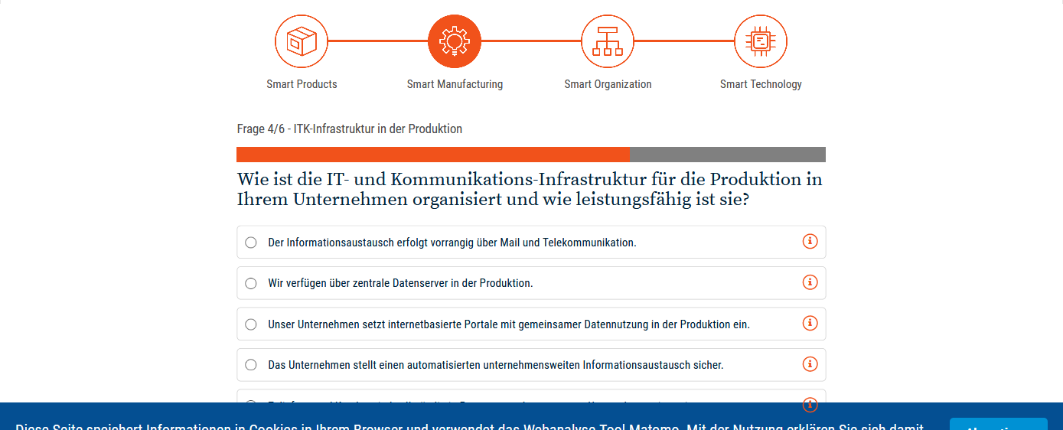
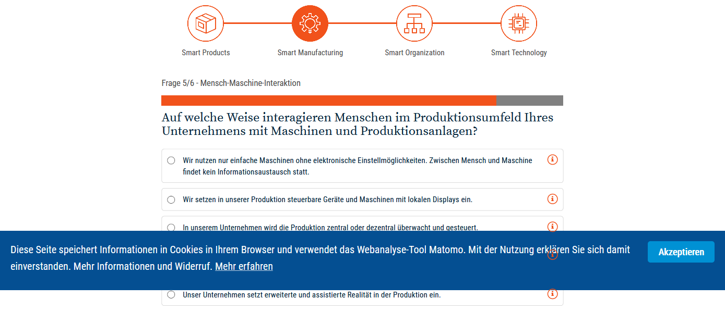
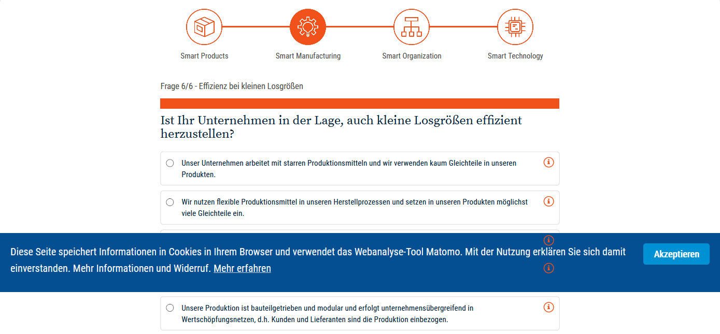
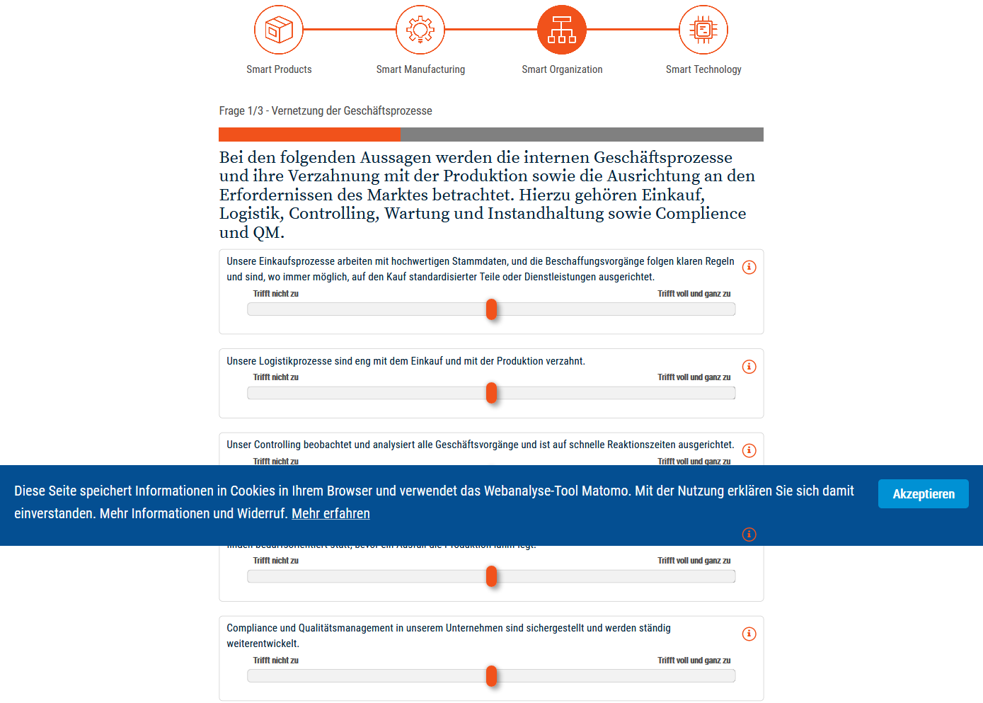
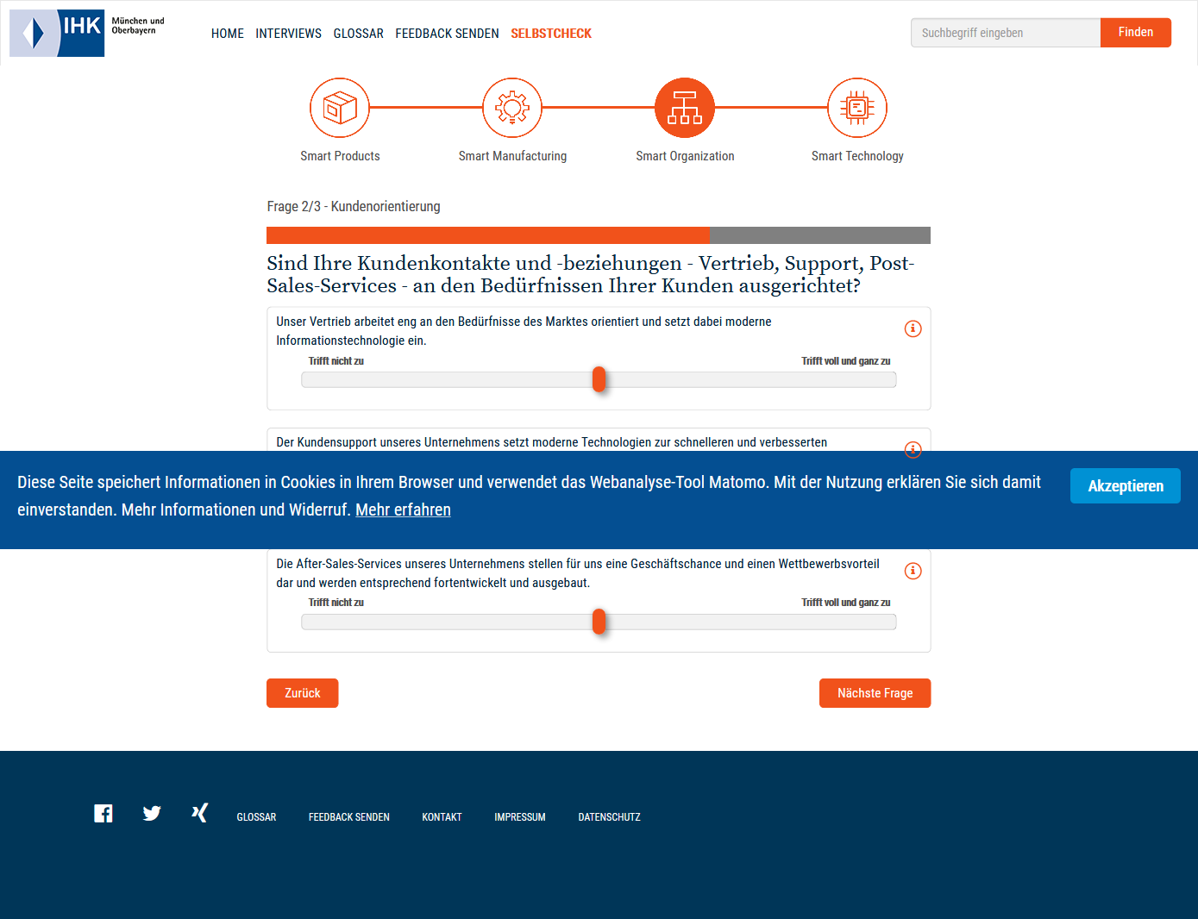
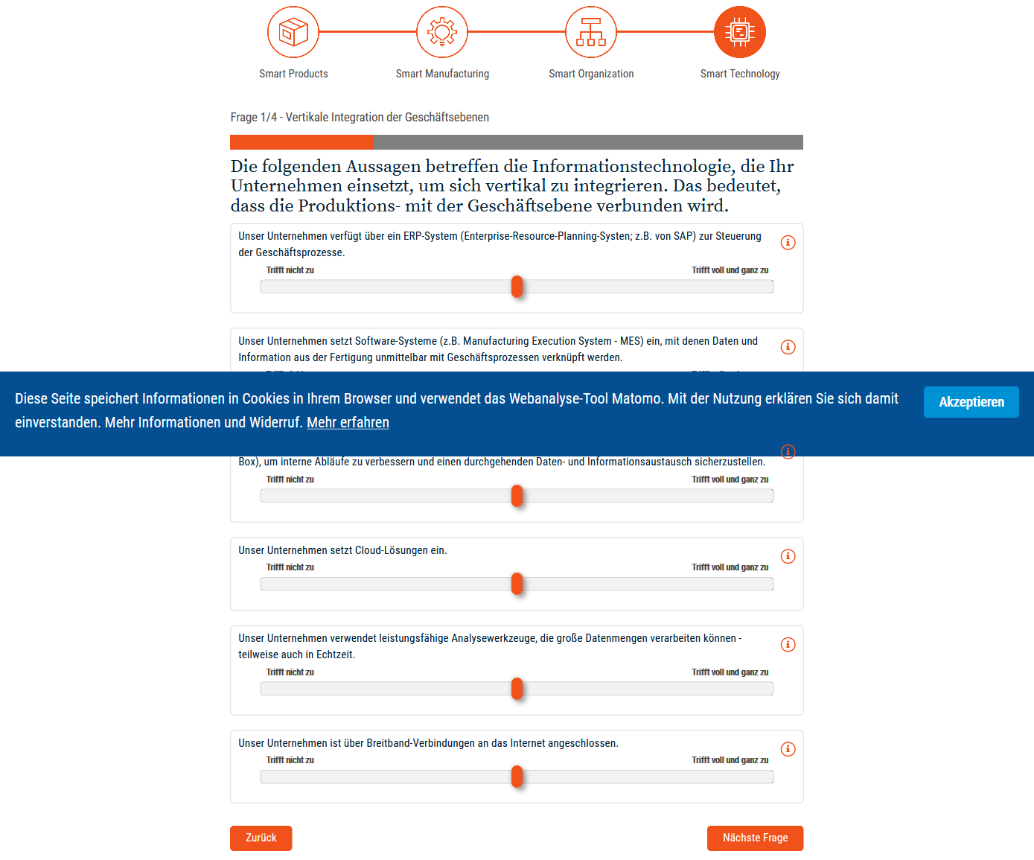
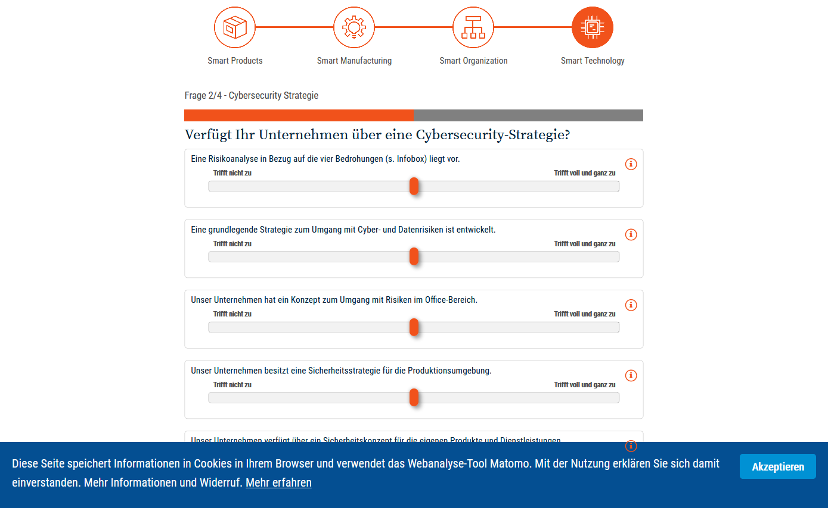
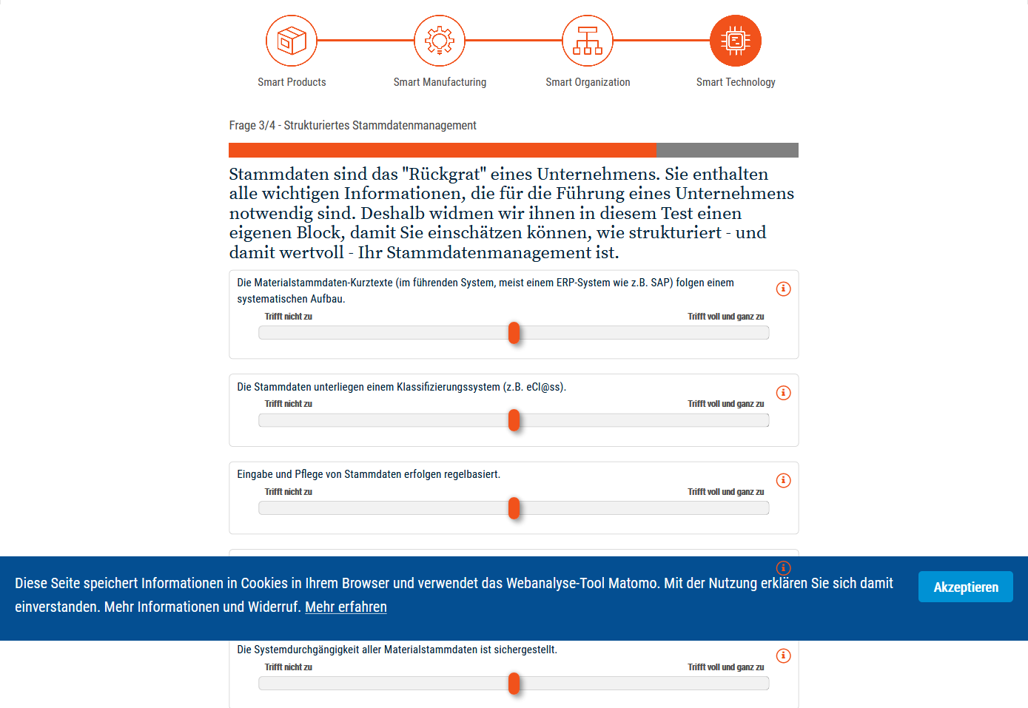

Industry 4.0-Readiness, online-Self-Check (IMPULS)

Benchmark Readiness I4.0
Das Benchmarkingzur Readiness I 4.0 betrachtet die Anschlussfähigkeit der Produktionsorganisation an Industrie 4.0-Konzepteund umfasst 9 Indikatoren:
- Softwareorientierung für eine intelligente Produktion
  - IT gestützte Produktionsplanung
Wird in Ihrem Betrieb ein Softwaresystem zur Produktionsplanung und -steuerung eingesetzt (z. B. ERP-System)? [Ja/Nein]
  - Echtzeitnahes Produktionsleitsystem
Wird in Ihrem Betrieb ein Echtzeitnahes Produktionsleitsystem eingesetzt (z. B. Systeme mit zentraler Maschinen-/Prozessdatenerfassung, MES)? [Ja/Nein]
  - IT System für Supply-Chain-Management
Findet in Ihrem Betrieb ein Digitaler Datenaustausch mit Zulieferern bzw. Kunden (Supply-Chain-Management-Systeme) statt? [Ja/Nein]
  - IT System für Product Lifecycle Management
Wird in Ihrem Betrieb ein Product Lifecycle Management-Systeme (PLM) oder ggf. auch Pro-dukt-Prozessdaten-Management eingesetzt? [Ja/Nein]
- Prozessnahe Technologien für eine intelligente Produktion
  - IT gestützte Steuerung der internen Logistik
Wird in Ihrem Betrieb eine Technik zur Automatisierung und Steuerung der internen Logistik (z .B. Lagerverwaltungssysteme, RFID) eingesetzt? [Ja/Nein]
  - Mobile/Drahtlose Programmierung von Maschinen
Werden in Ihrem Betrieb mobile/drahtlose Geräte zur Programmierung und Bedienung von An-lagen und Maschinen (z. B. Tablets) eingesetzt? [Ja/Nein]
  - Sichere Mensch-Maschine-Kooperation
Werden in Ihrem Betrieb Technologien für eine sichere Mensch-Maschine-Kooperation (z. B. kooperative Roboter, „zaunfreie“ Stationen etc.) angewendet? [Ja/Nein]
  - Mobiler/Drahtloser Zugang zu Arbeitsanweisungen
Werden in Ihrem Betrieb digitale Lösungen zum Bereitstellen und Nutzen von Zeichnungen, Ar-beitsplänen oder Arbeitsanweisungen direkt am Arbeitsplatz des Werkers (z.B. Tablets, Smartphones) eingesetzt? [Ja/Nein]
- Investitionen in Maschinen und Anlagen in der Produktion
  - Investitionsumfang für Maschinen und Anlagen
Berechnet sich aus Umfang der Investitionen in Maschinen und Anlagen geteilt durch den ge-samten Jahresumsatz[%-Anteil am Umsatz]

Unmoderated Google translation
Benchmarking for Readiness I 4.0 considers the connectivity of the production organization to Industry 4.0 concepts and includes 9 indicators:
- Software orientation for intelligent production
  - a. IT-based production planning
Is a software system used for production planning and control in your company (e.g. ERP system)? [Yes No]
  - b. Real-time production control system
Is a real-time production control system used in your company (e.g. systems with central machine / process data acquisition, MES)? [Yes No]
  - c. IT system for supply chain management
Is there a digital data exchange in your company with suppliers or customers (supply chain management systems)? [Yes No]
  - d. IT system for product lifecycle management
Is a product lifecycle management system (PLM) or possibly product process data management used in your company? [Yes No]
- Process-related technologies for intelligent production
  - a. IT-based control of internal logistics
Is technology in your company used to automate and control internal logistics (e.g. warehouse management systems, RFID)? [Yes No]
  - b. Mobile / wireless programming of machines
Are mobile / wireless devices used in your company for programming and operating systems and machines (e.g. tablets)? [Yes No]
  - c. Safe human-machine cooperation
Are technologies used in your company for safe human-machine cooperation (e.g. cooperative robots, "fence-free" stations, etc.)? [Yes No]
  - d. Mobile / wireless access to work instructions
Are digital solutions used in your company to provide and use drawings, work plans or work instructions directly at the work place of the worker (e.g. tablets, smartphones)? [Yes No]
- Investments in machines and systems in production
  - a. Scope of investment for machines and systems
Calculated from the volume of investments in machines and systems divided by the total annual turnover [% - share of turnover]

Test Industria 4.0
Strategia - A0
A0.01 - Quanto considerate parte delle vostre strategie aziendali l’innovazione connessa a soluzioni di Industria 4.0?
A0.02 - Come percepite il vostro posizionamento circa soluzioni Industry 4.0 rispetto ai vostri competitor esistenti o potenziali?
A0.03 - Quanto Industry 4.0 è connessa allo sviluppo oltre che di modelli di business e operativi, di prodotti dotati di caratteristiche e tecnologie proprie di questo nuovo paradigma?
A0.04 - Chi gestisce nella vostra organizzazione la definizione delle linee di sviluppo strategico di opportunità derivanti da Industry 4.0?
A0.05 - Quale è la fonte primaria di assistenza esterna (strategica, culturale ed implementativa) delle soluzioni Industry 4.0 nella vostra realtà?
A0.06 - Quali sono i principali vincoli/rischi che potrebbero frenare l’attivazione di iniziative in ambito Industry 4.0?
A0.07 - Quale è l’impatto ad oggi sugli aspetti economico-finanziari ed operativi delle soluzioni Industry 4.0 già applicate nella vostra organizzazione? Quale è, in percentuale, l’impatto positivo sull’incremento del fatturato piuttosto che sulla riduzione dei costi?
A0.08 - Quanto le vostre iniziative Industry 4.0 attivate o pianificate prevedono il coinvolgimento di più attori della catena del valore, interna (funzioni aziendali) ed esterna (clienti e fornitori)?
A0.09 - Ritenete la vostra cultura aziendale nel complesso matura in relazione alle tematiche di innovazione e trasformazione Industry 4.0?
A0.10 - Come viene riconosciuta, sviluppata e premiata la competenza Industry 4.0 nella vostra organizzazione?
Design and Engineering – A1
A1.01 - Quale di queste logiche viene utilizzata nel processo di sviluppo prodotto?
A1.02 - Come
A1.03 - L’azienda utilizza degli strumenti di simulazione nella fase di validazione del concept?
A1.04 - In che modo la funzione di produzione è coinvolta nella fase di design del prodotto?
A1.05 - Come sono gestite le diverse modifiche/versioni di sviluppo di un nuovo prodotto?
A1.06 - Come è gestito il passaggio della distinta base (BOM, Bill of Material) tra progettazione e produzione?
A1.07 - Come sono gestite le richieste di modifica (ECN, Engineering Change Note) nello sviluppo di un nuovo prodotto?
Pratiche di gestione del processo di sviluppo Esprimere quanto le seguenti condizioni si verificano in azienda. (1: Non esiste 2: Esiste un progetto pilota 3-4: implementato, ma a macchia di leopardo 5: Ampiamente e definitivamente implementato)
A1.08 - Approcci lean o agili sono consolidati per lo sviluppo prodotto, per cui abitualmente si parte nella definizione di un MVP (minimum viable product) che poi viene ampliato successivamente
A1.09 - Sono state condotte Value analysis/engineering o Variety Reduction Programs* per identificare opportunità di design finalizzate a eliminare ridondanze, cannibalizzazioni di prodotto, etc.
A1.10 - Gli operatori incontrano periodicamente i clienti interni (ed esterni) ed i fornitori al fine di eliminare gli sprechi/scarti e migliorare la qualità del prodotto
A1.11 - La qualità dei nuovi progetti di sviluppo prodotto viene misurata e mostra un miglioramento continuo
A1.12 - Come è realizzata la pianificazione del ciclo di lavorazione di un prodotto?
A1.13 - La vostra azienda implementa simulazioni di Virtual Commissioning per riprodurre il comportamento fisico dell’asset o dell’impianto - tecnicamente controllati da PLC o Motion Control o CNC e con HMI - in maniera virtuale al fine di testare i codici e rimuovere errori prima della costruzione delle componenti fisiche?
A1.14 - Viene bilanciato il carico di lavoro durante la progettazione del sistema produttivo?
Production Management– A2
A2.01 - Su cosa si basa il vostro sistema di pianificazione della produzione?
A2.02 - Quali delle informazioni necessarie alla stesura del piano aggregato di produzione (previsioni vendite, scorte, ordini, …) sono disponibili e ogni quanto vengono aggiornate nel piano?
A2.03 - Come si considera la capacità produttiva al momento della verifica del piano aggregato di produzione?
A2.04 - Come è definita la pianificazione degli approvvigionamenti di materiali?
A2.05 - Come avviene il lancio degli ordini nella programmazione di breve termine della produzione?
A2.06 - Quale supporto viene utilizzato per l’attività di pianificazione dei requisiti di capacità degli impianti produttivi?
A2.07 - Quale supporto viene utilizzato per l’attività di pianificazione dei requisiti di capacità (turnazione della manodopera)?
A2.08 - Quale supporto viene utilizzato per l’attività di controllo di esecuzione delle attività produttive, relativamente alla gestione degli Ordini di Lavoro?
A2.09 - Quale supporto viene utilizzato per l’attività di controllo di esecuzione movimenti lotti di produzione, sfusi, …, relativamente alla gestione del flusso dei materiali attraverso le diverse unità produttive?
A2.10 - Quale supporto viene utilizzato per l’attività di controllo dello stato del WIP nei magazzini inter-operazionali?
A2.11 - Quale supporto viene utilizzato per l’attività di gestione liste di dispatching con requisiti nell’ordine di lavoro (dispacciamento istruzioni lavoro, …)?
A2.12 - Quale supporto viene utilizzato per l’attività di rescheduling delle operazioni in caso di necessità dovute a eventi “dal campo” (necessità di modifica in base a priorità e, in generale, a eccezioni/disturbi occorsi nel sistema produttivo-logistico)?
A2.13 - Quale supporto viene utilizzato per l’attività di gestione della documentazione utile per garantire la conformità a norme di varia natura, i.e. ambiente, igiene, sicurezza (es. procedure associate alle operazioni, …)?
A2.14 - Quale supporto viene utilizzato per l'attività di reporting sullo stato di utilizzo dei macchinari / impianti, con relativi indici di efficienza (es. OEE)?
A2.15 - Quale supporto viene utilizzato per l’attività di reporting sull’efficienza degli operatori?
A2.16 - Quale supporto viene utilizzato per l’attività di reporting sui tempi di attraversamento dei lotti di produzione?
A2.17 - Che tipo di abilità (skill) caratterizza il vostro personale di produzione?
A2.18 - Come sono mantenute e utilizzate le informazioni storiche disponibili dal monitoraggio della prestazioni tecniche di produzione?
A2.19 - Come sono mantenute e utilizzate le informazioni storiche disponibili dal monitoraggio dei costi di produzione?
Pratiche di implementazione del sistema qualità in produzione Esprimere quanto le seguenti condizioni si verificano in azienda. (1: Non esiste 2: Esiste un progetto pilota 3-4: implementato, ma a macchia di leopardo 5: Ampiamente e definitivamente implementato)
A2.20 - Le distanze sulla linea sono state studiate e ridotte al minimo avvicinando tra loro stazioni di lavoro successive e utensili (es. approvvigionamento minuteria, utilizzo attrezzatura specifica)
A2.21 - Gli elementi difettosi sono immediatamente rilevati all'interno dei processi produttivi (Es. quasi mai un pezzo difettoso supera i controlli e raggiunge la stazione produttiva a valle)
A2.22 - I processi e la strumentazione sono disposti in modo tale da assicurare un continuo flusso produttivo e non disposti a isola o a gruppi di processo
A2.23 . Esistono e sono visibili dei supporti informativi (es. cartelloni) in tutto lo stabilimento in cui vengono mostrate le istruzioni sulla sicurezza, sulle operazioni vietate, quelle necessarie, KPI, i problemi sulla qualità e le relative contromisure.
A2.24 - Esistono e sono visibili dei supporti informativi (check-list) che descrivono e tengono traccia per ogni macchinario delle problematiche possibili rilevabili sui pezzi lavorati.
A2.25 - Esiste una comunicazione efficace tra gli operatori impegnati sui diversi turni di produzione nell'impianto, anche attraverso strumenti di tipo non sincrono. (Es. attrezzatura difettosa, turni spostati, aree di produzione ecc.).
A2.26 - I processi produttivi sono attrezzati con luci o segnali di emergenza che gli operatori o le macchine stesse possono attivare in caso di necessità
A2.27 - Gli operatori possono fermare la linea quando un'unità difettosa viene rilevata o quando non possono completare l'attività prevista secondo le procedure di operatività standardizzate
A2.28 - Sono state definite delle procedure di operative standard (SOP) e sono utilizzate per istruire gli operatori per ogni processo produttivo
Quality Mangement– A3
A3.01 - L’azienda adotta un Sistema di Gestione della Qualità? Se sì, quali sono gli ambiti in cui interviene?
A3.02- Sono disponibili procedure per la gestione della qualità delle attività commerciali, degli approvvigionamenti, della progettazione e sviluppo e della produzione?
A3.03 - Quali sono i controlli di qualità che sono stati definiti e che vengono eseguiti da personale competente?
A3.04 - L’azienda ha definito una procedura per la gestione dei problemi di qualità?
A3.05 - In azienda eseguite un’analisi dei rischi per la stesura del piano di controllo tenendo conto del contesto, delle parti interessate e dei fattori che possono influenzare la qualità del prodotto?
A3.06 - Esistono dei sistemi informativi che permettono il tracciamento e l’accesso e supportano l’analisi dei dati relativi alle misurazioni di qualità in produzione?
A3.07 - Ogni quanto vengono analizzati i dati risultanti dalle ispezioni/prove di qualità?
A3.08 - In azienda vengono utilizzati strumenti e metodi standardizzati a supporto dell’analisi dei problemi di qualità atti all’individuazione degli ambiti e delle modalità di intervento e delle azioni di miglioramento?
A3.09 - Come interagisce il dipartimento di qualità con le atre funzioni aziendali?
Pratiche di gestione della qualità di sistema Esprimere quanto le seguenti condizioni si verificano in azienda. (1: Non esiste 2: Esiste un Pilota 3-4: A macchia di leopardo 5: E’già stato implementato)
A3.10 - Esiste un processo formale per gli operatori di produzione per ricevere regolarmente feedback sui problemi rilevati nei processi a valle Controllo
A3.11 - Esiste un processo formale che fornisca agli operatori l’opportunità di lavorare in gruppo per identificare problematiche legate alle performance, alla qualità o ai problemi di sicurezza Organizzazione
A3.12 - Gli operatori comprendono e possono utilizzare metriche di performance per monitorare e migliorare i processi produttivi Organizzazione
A3.13 - Quando vengono rilevate delle problematiche legate alla produzione si cerca di investigarle nei primi 10 minuti dalla rilevazione Esecuzione
A3.14 - Gli ingegneri di produzione e lo staff di supporto sistematicamente osservano le zone dove si sono verificati dei problemi di produzione e cercano di comprenderne le cause con gli operatori Esecuzione
A3.15 - Esiste un processo formale per la generazione di idee e suggerimenti da parte degli operatori e per il riconoscimento della loro partecipazione Organizzazione
A3.16 - Gli operatori sono stati istruiti sulle metodologie di miglioramento continuo e sono stati coinvolti o hanno partecipato in un progetto di miglioramento continuo Organizzazione
A3.17 - Gli operatori sono attivamente coinvolti nell’identificazione degli sprechi nei processi in cui sono coinvolti e sono stati abilitati a lavorare per ridurre o eliminare tali sprechi Organizzazione
A3.18 - La qualità esterna ai clienti viene misurata in base alle performance temporali, ai costi di garanzia e ai rendimenti Controllo
Maintenance Management– A4
A4.01 - Indicare il valore di bilancio delle immobilizzazioni in impianti e macchinari (AIDA):
A4.02 - Come sono organizzate le attività di manutenzione?
A4.03 - Come definite i piani di manutenzione nella vostra azienda?
A4.04 - Quale politica manutentiva è adottata dall’azienda?
A4.05 - Realizzate in azienda un’analisi dei guasti per identificare le macchine / sedi tecniche critiche per l’impianto?
A4.06 - Come viene utilizzata la criticità per lo sviluppo delle politiche di gestione dei materiali di ricambio?
A4.07 - Che informazioni vengono gestite nell’ordine di lavoro all’interno del processo di esecuzione della manutenzione?
A4.08 - Come fate le analisi dei dati provenienti da ispezioni / monitoraggio e come prendete le decisioni di manutenzione su condizione?
A4.09 - Gli strumenti impiegati per la manutenzione su condizione sono stati integrati “in rete”, al fine di fornire una connessione remota / accesso al sistema informativo di manutenzione?
A4.10 - Gli strumenti di monitoraggio / ispezione delle condizioni sono stati connessi a strumenti per la diagnostica e/o prognostica del guasto?
A4.11 - Realizzate in azienda un’analisi del magazzino per identificare i materiali di ricambio critici per l’impianto?
A4.12 - Come interagisce il dipartimento di manutenzione con quello di produzione?
A4.13 - Qual è il livello di responsabilizzazione (empowerment) del vostro personale di manutenzione?
Logistics Management– A5
A5.01 - Quali tecnologie vengono utilizzate per controllare operativamente il magazzino (posizionamento dei materiali, situazione inventariale)?
A5.02 - Quali metodi e processi utilizzate per l’allocazione dei materiali alle posizioni di magazzino, e con che frequenza viene rivista l’allocazione?
A5.03 - Quali pratiche della lean production avete adattato e applicato alle attività della logistica interna?
A5.04 - Quali strumenti e tecnologie si usano a supporto del processo di picking per l’alimentazione verso i reparti produttivi dei materiali gestiti a fabbisogno?
A5.05 - Come vengono misurate le prestazioni della logistica interna?
A5.06 - Come viene effettuato il dimensionamento ed il revamping degli asset di Materials Storage (Scaffalature portapallet, rulliere a gravità, cantilevar, magazzini verticali, ecc.) e Materials handling (Carrelli elevatori, carrelli commissionatori, rulliere, AGV, ecc.)?
Supply-Chain Management– A6
A6.01 - Come è strutturato il processo di Demand planning (previsione della domanda, gestione delle promozioni, gestione dei picchi di richiesta)?
A6.02 - Quali sistemi e applicazioni sono utilizzati a supporto del processo di Demand planning?
A6.03 - Come è strutturato il processo di Inventory planning (posizionamento delle scorte, selezione dei codici da gestire a scorta, scelta dei modelli di inventory management ottimali, definizione dei parametri come livello di riordino e scorte di sicurezza)?
A6.04 - Quali sistemi e applicazioni sono utilizzati a supporto del processo di Inventory planning?
A6.05 - Come è fatto il processo di pianificazione aggregata (comprendendo sia la pianificazione della capacità produttiva interna e dei fornitori, sia il bilanciamento domanda – capacità)?
A6.06 - Quali strumenti utilizzate a supporto del ciclo attivo ordine-consegna-fatturazione-pagamento?
A6.07 - Quali strumenti utilizzate a supporto del ciclo passivo ordine-consegna-fatturazione-pagamento?
A6.08 - Come tracciate i flussi fisici nella supply chain, sia a monte sia a valle (control-tower)?
A6.09 - Come è strutturato il vostro sistema di Vendor rating?
A6.10 - Come è strutturato il vostro processo di Supply Chain Risk Management?
Smart product – A7
A7.01 - Quali sono i principali componenti che caratterizzano il prodotto?
A7.02 - Quali sono le funzionalità aggiuntive che il prodotto è in grado di offrire?
A7.03 - A chi vengono comunicati i dati raccolti automaticamente relativi al prodotto?
A7.04 - Grazie ai dati comunicati, il fornitore è in grado di offrire servizi aggiuntivi ai propri clienti?
A7.05 - Come vengono implementate azioni correttive sul prodotto a fronte dei dati comunicati in real-time?
A7.06 - Come vengono comunicati e resi disponibili i dati relativi al prodotto?
Human Resource Management– A8
A8.01 - Avete definito dei ruoli di leadership e coordinamento per la realizzazione della strategia di Industria 4.0?
A8.02 - Quanto è coinvolta la funzione di gestione delle risorse umane nello sviluppo della strategia Industria 4.0?
A8.03 - Avete un processo di valutazione delle competenze dei vostri operatori per realizzare la strategia Industria 4.0?
A8.04 - Avete dei programmi di formazione per il personale sui temi di Industria 4.0?
A8.05 - Avete un programma per attrarre e trattenere il personale qualificato?
A8.06 - Come valutate l’allineamento tra i meccanismi premianti e gli obiettivi di Industria 4.0?
A8.07 - Quale è il livello di coinvolgimento dei dipendenti nei processi di cambiamento, come Industria 4.0?
A8.08 - Quale è il livello di digitalizzazione dei processi di gestione delle risorse umane?
A8.09 - Avete pianificato degli investimenti in tecnologie per migliorare le condizioni di lavoro dei dipendenti?
Marketing, Customer Care e Vendite – A9
A9.01 - Quanto siete consapevoli del posizionamento dei vostri clienti?
A9.02 - Che tipo di informazioni relative alla vostra azienda sono reperibili online?
A9.03 - Quali sono le vostre politiche di marketing su brand, prodotti e servizi offerti?
A9.04 - Come viene presentato il brand ed i prodotti/servizi offerti?
A9.05 - Come viene reso disponibile il catalogo dei prodotti e/o servizi offerti?
A9.06 - Come viene gestito il processo di definizione delle campagne promozionali e degli sconti?
A9.07 - Quali sono i canali di vendita utilizzati dall'azienda?
A9.08 - La vostra piattaforma di vendita online offre servizi evoluti (es. servizi supplementari come condizioni commerciali specifiche per clienti, scontistica dipendente dagli altri acquisti nel carrello)?
A9.09 - Con quale finalità raccogliete dati (anagrafici e comportamentali) sui clienti?
A9.10 - Realizzate prototipi (Proof of Concept) con tecnologie di prototipazione rapida al fine di comunicare e testare nuovi prodotti con i clienti?
A9.11 - Come definite le vostre stime di vendita?
A9.12 - Come integrate i vostri obiettivi di vendita tra quelli realizzati attraverso i canali tradizionali e quelli realizzati attraverso e-commerce?
A9.13 - Come avviene l’analisi della concorrenza?
A9.14 - A chi è affidata la gestione dei processi di customer care e servizi post vendita?
A9.15 - Quale strumento utilizzate a supporto delle attività di customer care ed assistenza clienti post-vendita?
A9.16 - Come monitorate e misurate la soddisfazione del cliente?
A9.17 - Come sono gestiti i processi di customer care ed assistenza clienti?
A9.18 - Quali sono e come sono utilizzati i dati e le informazioni destinate alla funzione di Customer Care e Post Vendita?
A9.19 - Qual è il livello di dematerializzazione documentale in azienda? Come la dematerializzazione documentale influenza le attività di customer care?

Unmoderated Google translation:
Strategy - A0
A0.01 - How much do you consider innovation connected to Industry 4.0 solutions as part of your business strategies?
A0.02 - How do you perceive your position regarding Industry 4.0 solutions compared to your existing or potential competitors?
A0.03 - How much Industry 4.0 is connected to the development, in addition to business and operational models, of products with the characteristics and technologies of this new paradigm?
A0.04 - Who manages in your organization the definition of the strategic development lines of opportunities deriving from Industry 4.0?
A0.05 - What is the primary source of external assistance (strategic, cultural and implementation) of Industry 4.0 solutions in your reality?
A0.06 - What are the main constraints / risks that could slow the activation of Industry 4.0 initiatives?
A0.07 - What is the impact to date on the economic-financial and operational aspects of Industry 4.0 solutions already applied in your organization? What is, in percentage terms, the positive impact on increasing turnover rather than reducing costs?
A0.08 - How much do your Industry 4.0 initiatives activated or planned involve the involvement of multiple actors in the value chain, internal (company functions) and external (customers and suppliers)?
A0.09 - Do you think your company culture is maturing on the whole in relation to innovation and transformation Industry 4.0 issues?
A0.10 - How is Industry 4.0 competence recognized, developed and rewarded in your organization?
Design and Engineering - A1
A1.01 - Which of these logics is used in the product development process?
A1.02 – How
A1.03 - Does the company use simulation tools in the concept validation phase?
A1.04 - How is the production function involved in the product design phase?
A1.05 - How are the different changes / development versions of a new product managed?
A1.06 - How is the passage of the bill of material (BOM) between design and production managed?
A1.07 - How are Engineering Change Notes (ECN) managed in the development of a new product?
Development Process Management Practices Express how the following conditions occur in the company. (1: There is no 2: There is a pilot project 3-4: implemented, but in a leopard spot 5: Widely and definitively implemented)
A1.08 - Lean or agile approaches are consolidated for product development, so we usually start by defining a MVP (minimum viable product) which is then expanded later
A1.09 - Value analysis / engineering or Variety Reduction Programs * were conducted to identify design opportunities aimed at eliminating redundancies, product cannibalizations, etc.
A1.10 - Operators periodically meet internal (and external) customers and suppliers in order to eliminate waste / scraps and improve product quality
A1.11 - The quality of new product development projects is measured and shows continuous improvement
A1.12 - How is the production cycle planning carried out?
A1.13 - Your company implements Virtual Commissioning simulations to reproduce the physical behavior of the asset or plant - technically controlled by PLC or Motion Control or CNC and with HMI - in a virtual way in order to test the codes and remove errors before building physical components?
A1.14 - Is the workload balanced during the design of the production system?
Production Management - A2
A2.01 - What is your production planning system based on?
A2.02 - Which of the information necessary for drawing up the aggregate production plan (sales forecasts, stocks, orders, ...) are available and how often are they updated in the plan?
A2.03 - How is production capacity considered when checking the aggregate production plan?
A2.04 - How is the planning of material supplies defined?
A2.05 - How is the launch of orders in the short-term planning of production?
A2.06 - Which support is used for the planning of the capacity requirements of the production plants?
A2.07 - Which support is used for the planning of capacity requirements (labor shifts)?
A2.08 - What support is used for the control of the execution of production activities, relating to the management of Work Orders?
A2.09 - Which support is used for the control of the execution of movements of production batches, in bulk, ..., relating to the management of the flow of materials through the various production units?
A2.10 - Which support is used for checking the status of the WIP in inter-operational warehouses?
A2.11 - What support is used for the dispatching list management activity with requirements in the work order (dispatching work instructions, ...)?
A2.12 - Which support is used for the rescheduling of operations in case of need due to events "from the field" (need to change based on priorities and, in general, to exceptions / disturbances occurred in the production-logistics system )?
A2.13 - Which support is used for the management of documentation useful for ensuring compliance with various types of standards, i.e. environment, hygiene, safety (e.g. procedures associated with operations, ...)?
A2.14 - What support is used for reporting on the state of use of machinery / plants, with related efficiency indices (eg OEE)?
A2.15 - What support is used for reporting on operator efficiency?
A2.16 - Which support is used for reporting on the time required to cross production batches?
A2.17 - What type of skill characterizes your production staff?
A2.18 - How is the historical information available from monitoring production technical performance maintained and used?
A2.19 - How is historical information available from production cost monitoring maintained and used?
Implementation practices of the quality system in production Express how much the following conditions occur in the company. (1: There is no 2: There is a pilot project 3-4: implemented, but in a leopard spot 5: Widely and definitively implemented)
A2.20 - The distances on the line have been studied and reduced to a minimum by bringing successive work stations and tools together (e.g. small parts supply, use of specific equipment)
A2.21 - Defective elements are immediately detected within the production processes (e.g. almost never a defective piece passes the checks and reaches the production station downstream)
A2.22 - The processes and instrumentation are arranged in such a way as to ensure a continuous production flow and not arranged in isolation or in process groups
A2.23. Information supports (e.g. placards) exist and are visible throughout the factory where safety instructions, prohibited operations, necessary operations, KPIs, quality problems and related countermeasures are shown.
A2.24 - There are and are visible information supports (check-lists) which describe and keep track of each possible problem that can be detected on the machined pieces.
A2.25 - There is effective communication between the operators engaged on the various production shifts in the plant, also through non-synchronous instruments. (E.g. defective equipment, shifted shifts, production areas etc.).
A2.26 - The production processes are equipped with emergency lights or signals that operators or machines themselves can activate in case of need
A2.27 - Operators can stop the line when a defective unit is detected or when they cannot complete the scheduled activity according to the standardized operating procedures
A2.28 - Standard operating procedures (SOP) have been defined and are used to instruct operators for each production process
Quality Management - A3
A3.01 - Does the company adopt a Quality Management System? If so, what are the areas in which it operates?
A3.02- Are procedures available for the quality management of commercial activities, supplies, design and development and production?
A3.03 - What are the quality controls that have been defined and that are performed by competent personnel?
A3.04 - Has the company defined a procedure for managing quality problems?
A3.05 - Do you carry out a risk analysis in the company for the preparation of the control plan taking into account the context, the interested parties and the factors that can influence the quality of the product?
A3.06 - Are there information systems that allow tracking and access and support the analysis of data relating to quality measurements in production?
A3.07 - How often are the data resulting from quality inspections / tests analyzed?
A3.08 - Are standardized tools and methods used in the company to support the analysis of quality problems aimed at identifying areas and methods of intervention and improvement actions?
A3.09 - How does the quality department interact with the other company functions?
System Quality Management Practices Express how the following conditions occur in the company. (1: There is no 2: There is a Pilot 3-4: Leopard spot 5: It has already been implemented)
A3.10 - There is a formal process for production operators to regularly receive feedback on problems detected in the downstream processes
A3.11 - There is a formal process that provides operators with the opportunity to work in a team to identify issues related to performance, quality or safety issues. Organization
A3.12 - Operators understand and can use performance metrics to monitor and improve Organization production processes
A3.13 - When production-related problems are detected, an attempt is made to investigate them within the first 10 minutes of the Execution survey
A3.14 - The production engineers and the support staff systematically observe the areas where production problems have occurred and try to understand the causes with the operators Execution
A3.15 - There is a formal process for the generation of ideas and suggestions by operators and for the recognition of their participation Organization
A3.16 - The operators have been instructed on continuous improvement methodologies and have been involved in or participated in a continuous improvement project Organization
A3.17 - Operators are actively involved in the identification of waste in the processes in which they are involved and have been enabled to work to reduce or eliminate such waste Organization
A3.18 - External quality to customers is measured on the basis of temporal performances, warranty costs and Control returns
Maintenance Management - A4
A4.01 - Indicate the book value of fixed assets in plant and machinery (AIDA):
A4.02 - How are maintenance activities organized?
A4.03 - How do you define the maintenance plans in your company?
A4.04 - Which maintenance policy is adopted by the company?
A4.05 - Do you carry out a failure analysis in the company to identify critical machines / technical sites for the system?
A4.06 - How is the criticality used for the development of spare parts management policies?
A4.07 - What information is managed in the work order within the maintenance execution process?
A4.08 - How do you analyze data from inspections / monitoring and how do you make condition-based maintenance decisions?
A4.09 - Have the tools used for on-condition maintenance been integrated "in network", in order to provide a remote connection / access to the maintenance information system?
A4.10 - Have the conditions monitoring / inspection tools been connected to tools for diagnostics and / or prognostics of the fault?
A4.11 - Do you carry out a warehouse analysis in the company to identify critical replacement materials for the system?
A4.12 - How does the maintenance department interact with the production department?
A4.13 - What is the level of empowerment of your maintenance staff?
Logistics Management - A5
A5.01 - What technologies are used to operationally control the warehouse (positioning of materials, inventory situation)?
A5.02 - What methods and processes do you use to allocate materials to warehouse locations, and how often is the allocation reviewed?
A5.03 - Which lean production practices have you adapted and applied to the internal logistics activities?
A5.04 - What tools and technologies are used to support the picking process for feeding the materials managed on demand to the production departments?
A5.05 - How are internal logistics performances measured?
A5.06 - How is the sizing and revamping of the Materials Storage assets (Pallet racking, gravity roller conveyors, cantilevars, vertical warehouses, etc.) and Materials handling (Forklifts, order pickers, roller conveyors, AGVs, etc.)?
Supply-Chain Management– A6
A6.01 - How is the demand planning process structured (demand forecasting, promotion management, peak demand management)?
A6.02 - Which systems and applications are used to support the demand planning process?
A6.03 - How is the Inventory planning process structured (inventory positioning, selection of codes to manage in stock, choice of optimal inventory management models, definition of parameters such as level of reorganization and safety stocks)?
A6.04 - Which systems and applications are used to support the inventory planning process?
A6.05 - How is the aggregate planning process done (including both planning of internal production capacity and suppliers, and demand - capacity balancing)?
A6.06 - Which tools do you use to support the order-delivery-billing-payment active cycle?
A6.07 - What tools do you use to support the passive cycle order-delivery-billing-payment?
A6.08 - How do you track physical flows in the supply chain, both upstream and downstream (control-tower)?
A6.09 - How is your Vendor rating system structured?
A6.10 - How is your Supply Chain Risk Management process structured?
Smart product - A7
A7.01 - What are the main components that characterize the product?
A7.02 - What are the additional features that the product is able to offer?
A7.03 - To whom are the automatically collected data relating to the product communicated?
A7.04 - Thanks to the data communicated, is the supplier able to offer additional services to its customers?
A7.05 - How are corrective actions implemented on the product against the data communicated in real-time?
A7.06 - How are product data communicated and made available?
Human Resource Management– A8
A8.01 - Have you defined leadership and coordination roles for the implementation of the Industry 4.0 strategy?
A8.02 - How much is the human resource management function involved in the development of the Industry 4.0 strategy?
A8.03 - Do you have a process of assessing the skills of your operators to implement the Industry 4.0 strategy?
A8.04 - Do you have training programs for personnel on Industry 4.0 issues?
A8.05 - Do you have a program to attract and retain qualified personnel?
A8.06 - How do you evaluate the alignment between the reward mechanisms and the objectives of Industry 4.0?
A8.07 - What is the level of employee involvement in change processes, such as Industry 4.0?
A8.08 - What is the level of digitization of human resource management processes?
A8.09 - Have you planned investments in technologies to improve the working conditions of employees?
Marketing, Customer Care and Sales - A9
A9.01 - How aware are you of the positioning of your customers?
A9.02 - What kind of information about your company can be found online?
A9.03 - What are your marketing policies on brands, products and services offered?
A9.04 - How is the brand and the products / services offered presented?
A9.05 - How is the catalog of products and / or services offered made available?
A9.06 - How is the process of defining promotional campaigns and discounts managed?
A9.07 - What are the sales channels used by the company?
A9.08 - Does your online sales platform offer advanced services (e.g. additional services such as specific commercial conditions for customers, discounts depending on other purchases in the cart)?
A9.09 - For what purpose do you collect data (personal and behavioral) about customers?
A9.10 - Do you make prototypes (Proof of Concept) with rapid prototyping technologies in order to communicate and test new products with customers?
A9.11 - How do you define your sales estimates?
A9.12 - How do you integrate your sales objectives between those achieved through traditional channels and those achieved through e-commerce?
A9.13 - How does the competition analysis take place?
A9.14 - Who is entrusted with the management of customer care processes and after sales services?
A9.15 - What tool do you use to support customer care activities and after-sales customer assistance?
A9.16 - How do you monitor and measure customer satisfaction?
A9.17 - How are customer care and customer support processes managed?
A9.18 - What are the data and information used for the Customer Care and After Sales function and how are they used?
A9.19 - What is the level of document dematerialisation in the company? How does document dematerialisation influence customer care activities?

MP³rove Digital Innovation Quotient
Digital innovation strategy
- General objectives for digital innovation
What are your general objectives for digital innovation? For which do you allocate resources to drive digital innovation? [Please tick all the items that are fully applicable. You may specify more than one answer. If none of the items is applicable or if you do not have the relevant information to provide an answer, please select N/A.]
 | Please tick if objectives have been defined | Please tick if resources have been allocated to meet objectives
Increase revenue with digital innovation
Decrease cost with digital innovation
Increase process speed with digital innovation
Increase adaptability with digital innovation
Develop new assets (material or immaterial) with digital innovation
Increase brand recognition with digital innovation
Increase integration in value networks with digital innovation
Enhance sustainability with digital innovation
Other, please specify (in English language)

- Functional scope for digital innovation
In which of the following functions do you have objectives for digital innovation? For which do you allocate resources to drive digital innovation? [Please tick all the items that are fully applicable. You may specify more than one answer. If none of the items is applicable or if you do not have the relevant information to provide an answer, please select N/A.]
 |  | Please tick if objectives have been defined | Please tick if resources have been allocated to meet objectives | N/A
Customer contact points | After-sales services
 | Sales
 | Marketing
Value generation and delivery | Operations
 | Procurement and partner management
 | Development
Administration | Finance
 | HR
 | IT

- Digital innovation trends affecting the firm
To what extent are the following digital innovation trends relevant to your firm? And to what extent have you already addressed each trend by dedicating resources? [On a scale from 0-4, please specify the answer by selecting from the drop-down menu based on the following logic: 0 – not at all 1 – to a small extent 2 – to a moderate extent 3 – to a large extent 4 – to a very large extent]
 |  | Relevant to your firm | Addressed by your firm | N/A
Consumer behaviour | Growing customer (buying) power
 | Anything, anywhere and anytime expectations
 | From physical to digital offerings
 | From ownership to usage of products and services
Data and information | Data-driven process optimisation
 | Data-driven forecasting to support decision-making
 | From human judgement to machine judgement
 | Growing cyber security concerns
Connectivity | Customisation
 | Collaboration with external networks for value generation
 | Augmented or virtual reality for enhanced productivity
 | Growth of online communities of clients
Value network | Business development in partnerships
 | Digitalisation of processes
 | Process integration with partners

- Characteristics of digital innovation strategy
Which of the following attributes apply regarding your digital innovation strategy? [Please tick all the items that are fully applicable. You may specify more than one answer. If the question does not apply or if you do not have the relevant information to provide an answer, please select N/A.]
 |  | Please tick all that apply
We do not have a digital innovation strategy
We have a digital innovation strategy | It builds on an analysis of digital innovation trends
 | It is documented in writing (either as part of a wider strategy document or as a separate strategy document)
 | It is aligned with our firm's strategy
 | It provides specific innovation objectives
 | It helps us to focus our investments on digital innovation
 | It contains specific digital innovation initiatives with defined implementation plans
 | It clearly links digital innovation activities to financial business objectives (e.g. revenue growth or cost savings)
 | Our employees are aware of its key objectives
 | Our digital innovation partners are aware of its key objectives
 | It builds on an analysis of digital innovation trends
 | It is documented in writing (either as part of a wider strategy document or as a separate strategy document)
 | It is aligned with our firm's strategy
 | It provides specific innovation objectives
 | It helps us to focus our investments on digital innovation
 | It contains specific digital innovation initiatives with defined implementation plans
 | It clearly links digital innovation activities to financial business objectives (e.g. revenue growth or cost savings)
 | Our employees are aware of its key objectives
 | Our digital innovation partners are aware of its key objectives
- Revenue growth expectation
What is your firm's expected compound annual growth rate (CAGR) of revenue over the next three years? [Please use a number with one decimal place greater or equal -100, whereby positive values indicate a revenue increase and negative values indicate a revenue decrease. If you do not have the relevant information to provide an answer, please select N/A.]
Over the next three years
Expected compound annual growth rate (CAGR) of revenue (in %)
Digital business model
- Characteristics of customer interaction
Which of the following attributes apply to your interaction with customers? [On a scale from 0-4, please specify the answer based on the following logic: 0 – does not apply at all 1 – applies to a small extent 2 – applies to a moderate extent 3 – applies to a large extent 4 – applies to a very large extent]
 | 0 | 1 | 2 | 3 | 4 | N/A
We operate a company website with detailed information about our firm and our product (or service) offering
We operate an online shop that is intuitive and functional for all key customer profiles
We provide an app for mobile phones or tablets as an “anytime, anywhere” offer which is highly valued by our clients
We interact naturally with customers online in live chats, online forums and social media
We provide comprehensive and consistent information across digital and non-digital communication and marketing channels
We continuously capture customer feedbacks
We continuously optimise and / or innovate our digital customer interaction services

- Data capturing
To what extent do you capture data in the following functions? [For your answer, please consider data capturing related to the offering with the highest contribution to earnings before interest and taxes (EBIT) in the last three years. On a scale from 0-4, please specify the answer by selecting from the drop-down menu based on the following logic: 0 – not at all 1 – occasionally 2 – regularly, but manually 3 – regularly and automated 4 – continuously and automated]
 |  | 0 | 1 | 2 | 3 | 4 | N/A
Customer experience | Product or service usage by customer
Customer contact points | After-sales services
 | Sales
 | Marketing
Value generation and delivery | Operations
 | Procurement and partner management
 | Development
Administration | Finance
 | HR
 | IT
- Data analytics
To what extent do you systematically analyse data in-house across the following functions?
For your answer, please consider data analytics related to the offering with the highest contribution to earnings before interest and taxes (EBIT) in the last three years. [On a scale from 0-5, please specify the answer by selecting from the drop-down menu based on the following logic: 0 – no data analysis 1 – descriptive analysis to summarise data 2 – diagnostic analysis to investigate data 3 – predictive analysis to forecast data 4 – prescriptive analysis to derive recommended actions 5 – artificial intelligence to derive and exercise recommended actions which are dynamically adapted to environmental circumstances If the question does not apply or if you do not have the relevant information to provide an answer, please select N/A.]
 |  | 0 | 1 | 2 | 3 | 4 | 5 | N/A
Customer experience | Product or service usage by customer
Customer contact points | After-sales services
 | Sales
 | Marketing
Value generation and delivery | Operations
 | Procurement and partner management
 | Development
Administration | Finance
 | HR
 | IT
- Revenue
In the last year, what has been the revenue of your firm (in euros)? [Please tick the right answer option. If you do not have the relevant information to provide an answer, please select N/A.]
Select
Up to 2 million
More than 2 million and up to 10 million
More than 10 million and up to 50 million
More than 50 million and up to 100 million
More than 100 million and up to 250 million
More than 250 million and up to 500 million
More than 500 million and up to 750 million
More than 750 million and up to 1 billion
More than 1 billion and up to 10 billion
More than 10 billion and up to 50 billion
More than 50 billion

- Growth in revenue
What has been your firm's growth rate of revenue in the last year compared to the previous year? [Please use a number with one decimal place greater or equal -100, whereby positive values indicate a revenue increase and negative values indicate a revenue decrease. If you do not have the relevant information to provide an answer, please select N/A.]
Last year compared to the previous year
Growth rate of revenue (in %)

- Operational profit
In the last year, what have been your firm's earnings before interest and taxes (EBIT)? [Please use a number with one decimal place, whereby positive values indicate a profit and negative values indicate a loss. If you do not have the relevant information to provide an answer, please select N/A.]
Last year
Earnings before interest and taxes (EBIT) (in % of revenue)

- Growth in operational profit
What has been your firm's growth rate of earnings before interest and taxes (EBIT) in the last year compared to the previous year? [Please use a number with one decimal place, whereby positive values indicate an EBIT increase and negative values indicate an EBIT decrease. If you do not have the relevant information to provide an answer, please select N/A.]
Last year compared to the previous year
Growth rate of earnings before interest and taxes (EBIT) (in %)

- Growth in employees
What has been your firm's growth rate of full-time equivalent (FTE) employees in the last year compared to the previous year? [Please use a number with one decimal place greater or equal -100, whereby positive values indicate a FTE increase and negative values indicate a FTE decrease. If you do not have the relevant information to provide an answer, please select N/A.]
Last year compared to the previous year
Growth rate of full-time equivalent (FTE) employees (in %)

- Digital revenue
In the last year, what share of your revenue has been generated by the following categories of offerings? [For each cell, please use numbers with one decimal place between 0 and 100 and make sure that the sum of all entered values adds up to 100%. Please simply insert 0 for any category, which is not part of your product or service portfolio. If you do not have the relevant information to provide an answer, please select N/A.]
 |  | Share of revenue generated per category (in %)
Digital offerings | Digital offerings connected to internet or internet-of-things
 | Digital offerings without connection to internet or internet-of-things
Other offerings | Other offerings connected to internet or internet-of-things
 | Other offerings without connection to internet or internet-of-things
- Digital innovation
In the last year – and considering the same categories of offerings – what share of your revenue per category has been generated from innovation, i.e. offerings which are not more than three years old? [For each cell, please use numbers with one decimal place between 0 and 100. If all of your revenue is generated from innovation, please insert 100% for any category of offerings covered by your firm. If a category is not part of your product or service portfolio or if you do not have the relevant information to provide an answer, please select N/A.]
 |  | Share of revenue from innovation per category (in %)
Digital offerings | Digital offerings connected to internet or internet-of-things
 | Digital offerings without connection to internet or internet-of-things
Other offerings | Other offerings connected to internet or internet-of-things
 | Other offerings without connection to internet or internet-of-things

Digital processes
- Development process
How do you describe the development process for digital innovation in your firm? [On a scale from 0-4, please specify the answer based on the following logic: 0 – does not apply at all 1 – applies to a small extent 2 – applies to a moderate extent 3 – applies to a large extent 4 – applies to a very large extent]
 |  | 0 | 1 | 2 | 3 | 4 | N/A
Process type | We effectively use agile development methods for digital innovation (e.g. design thinking, rapid prototyping, scrum)
Process activity | We create or receive a large number of ideas for digital innovation
 | We set up a significant number of digital innovation projects
 | We run a significant share of long-term digital innovation projects to develop new capabilities
Process success | We generate high-quality ideas which have proven to be an excellent basis for digital innovation
 | We effectively select the best ideas for digital innovation and turn them into projects
 | We consistently achieve positive business impact with digital innovation projects
 | Our digital innovation strategy and specific customer needs consistently guide the development process
IT support | Our idea generation process for digital innovation is effectively supported by software
 | Our idea selection process for digital innovation is effectively supported by software
 | Our development process for digital innovation is effectively supported by software
- Time-to-market
How many months does it take for your most profitable offering in each of the following categories from the beginning of the development (i.e. project authorization) to getting the new or significantly improved offering on sale? [For each cell, please use numbers with one decimal place greater or equal 0. If several offerings exist per category, please select the offering with the highest contribution to earnings before interest and taxes (EBIT) in the last three years. If a category is not part of your product or service portfolio or if you do not have the relevant information to provide an answer, please select N/A.]
 |  | Time-to-market (in number of months)
Digital offerings | Digital offerings connected to internet or internet-of-things
 | Digital offerings without connection to internet or internet-of-things
Other offerings | Other offerings connected to internet or internet-of-things
 | Other offerings without connection to internet or internet-of-things
- Process automation for delivery of digital innovation
What degree of process automation does your firm experience today across the following functions?
For your answer, please focus on automation related to your offering with the highest contribution to earnings before interest and taxes (EBIT) in the last three years. [On a scale from 0-4, please specify the answer by selecting from the drop-down menu based on the following logic: 0 – no process automation at all 1 – some automation, high degree of unused potential to increase process speed or quality 2 – mass processing steps are automated, potential remains to increase process speed or quality 3 – mass processing steps are automated, good process speed and quality 4 – full process automation, systematic evaluation of further improvement potential]
 |  | 0 | 1 | 2 | 3 | 4 | N/A
Customer contact points | After-sales services
 | Sales
 | Marketing
Customer contact points | Operations
 | Procurement and partner management
 | Development
Customer contact points | Finance
 | HR
 | IT

- Utilisation and business impact of digital marketing
In the last year, to what degree have you utilised the following digital marketing options? And to what degree have you achieved measurable business impact with these options in the same period? [On a scale from 0-4, please specify the answer by selecting from the drop-down menu based on the following logic: 0 – not at all 1 – to a small extent 2 – to a moderate extent 3 – to a large extent 4 – to a very large extent]
 | Degree of utilisation | Degree of achieving measurable business impact | N/A
E-mail and newsletter marketing
Social media marketing
Affiliate marketing
Search engine marketing
Own (mobile) app marketing
Other

- Size of social media network
What is the current size of your social media network? [For each cell, please use integral numbers greater or equal 0. If the question does not apply or if you do not have the relevant information to provide an answer, please select N/A.]
 |  | Answer | N/A
Networks | Number of social media networks on which your firm is registered (in absolute values)
Contacts | Number of contacts in all social media networks on which your firm is registered (in absolute values)

- Revenue generated via digital sales channels
In the last year, what share of revenue has been generated via digital sales channels? [Please use a numbers with one decimal place between 0 and 100. If you do not have a digital sales channel or if you do not have the relevant information to provide an answer, please select N/A.]
Last year
Share of revenue generated via digital sales channels (in %)

Digital ecosystem and culture
- Organisation of digital innovation
How do you describe the organisation of digital innovation in your firm? [On a scale from 0-4, please specify the answer based on the following logic: 0 – does not apply at all 1 – applies to a small extent 2 – applies to a moderate extent 3 – applies to a large extent 4 – applies to a very large extent]
 | 0 | 1 | 2 | 3 | 4 | N/A
We have clearly defined the roles and responsibilities for digital innovation in our organisation
We strongly encourage the whole organisation to contribute or to take part in digital innovation activities
We define project-specific, cross-functional teams to address digital innovation challenges

- Governance of digital innovation
Who is leading the digital innovation agenda in your firm? [Please tick the right answer option. If you do not have the relevant information to provide an answer, please select N/A.
Note: The top management includes all managers reporting directly to the CEO or business owner.]
Select
Digital innovation agenda is led by the CEO or business owner
Digital innovation agenda is led by a dedicated top manager
Digital innovation agenda is led by a non-dedicated top manager
Digital innovation agenda is led by more than one top manager
Digital innovation agenda is led by mid-management
There is no clearly defined leader for the digital innovation agenda

- Contribution to digital innovation
In the last year, how many full-time equivalent (FTE) employees and how many external partners have contributed to idea generation, development and implementation of digital innovation initiatives in your firm? [For each cell, please use numbers with one decimal place greater or equal 0. If the question does not apply or if you do not have the relevant information to provide an answer, please select N/A.]
 | Full-time equivalent (FTE) employees with contribution (in absolute values) | Full-time equivalent (FTE) employees with contribution (in absolute values) | Full-time equivalent (FTE) employees with contribution (in absolute values)
Idea generation for digital innovation initiatives
Development of digital innovation initiatives
Implementation of digital innovation initiatives
N/A

- Business partner connection
When considering the last year, how do you characterise the interaction with your most important supplier and route-to-market partner (i.e. the partner distributing or selling your offerings)? [Please tick all the items that are fully applicable. You may specify more than one answer. If none of the items is applicable or if you do not have the relevant information to provide an answer, please select N/A.]
 | Key supplier | Key route-to-market partner
We are using digital interfaces beyond e-mail (e.g. web-portals)
We are using an automated process (e.g. steered based on algorithms)
We are exchanging data beyond transactional data (e.g. stock data)
We are exchanging data also with indirect partners (e.g. customers delivered via partners)
N/A

- Development of digital partner ecosystem
How do you rate your firm's capabilities to develop an ecosystem of partners which drive digital innovation? [On a scale from 0-4, please specify the answer based on the following logic: 0 – does not apply at all 1 – applies to a small extent 2 – applies to a moderate extent 3 – applies to a large extent 4 – applies to a very large extent]
 |  | 0 | 1 | 2 | 3 | 4 | N/A
Current network | Our current network allows us to implement our ambition for digital innovation for the next three years
Emerging network | Needs for digital innovation partnerships are identified systematically
 | For a specified need, a long-list of suitable digital innovation partners can easily be generated
 | We have fast processes to set-up new digital innovation partnerships
- General digital capabilities
What share of employees in your firm demonstrates the following digital capabilities? [For each cell, please use numbers with one decimal place between 0 and 100. If the question does not apply or if you do not have the relevant information to provide an answer, please select N/A.]
 |  | Share of employees demonstrating the respective type of capability (in %) | N/A
Use | Using state-of-the-art IT hardware or software
 | Operating digital or digitally supported business processes
Develop | Developing IT hardware or software
Participate | Communicating effectively in a variety of digital media
 | Collaborating effectively in virtual teams
Learn | Participating in digital learning opportunities

- Incentives for digital innovation
Which of the following monetary and non-monetary incentives for employees to contribute to digital innovation do you have in place? [Please tick all the items that are fully applicable. You may specify more than one answer. If the question does not apply or if you do not have the relevant information to provide an answer, please select N/A.]
 |  | Please tick all that apply
We do not have incentives for employees to contribute to digital innovation
We have incentives for employees to contribute to digital innovation | Monetary incentives
 | Staff recognition (formal or informal)
 | Training and professional development opportunities
 | Time budget to work on specific digital innovation topics
Other

Enablers for digital innovation
- Development of digital capabilities
How important are the digital capabilities of your current or future employees in the following dimensions across your firm? [On a scale from 0-4, please specify the answer based on the following logic: 0 – irrelevant 1 – a consideration 2 – expected 3 – important 4 – vital]
 | 0 | 1 | 2 | 3 | 4 | N/A
Digital capabilities of a job candidate in order to get recruited by your firm
Digital capabilities as an element of the overall employee training and capability development curriculum
Digital capabilities of an employee in order to get promoted internally to the next hierarchical level
Digital capabilities of a job candidate in order to get recruited by your firm

- Financial resources for digital innovation
Over the last three years, what average share of revenue has been spent on digital innovation projects? [Please use a number with one decimal place greater or equal 0. If the question does not apply or if you do not have the relevant information to provide an answer, please select N/A.
Note: The average share of revenue spent on digital innovation projects includes all operating expenditures and all capital expenditures (using the approximate annual depreciation) in as far as required to successfully commercialise new or enhanced digital and / or connected offerings (products, services or business models) or processes in a given year.]
Answer
Average share of revenue spent on digital innovation projects over the last three years (in %)

- Specialised expertise in IT, risk management, legal and tax affairs
To what degree are the following areas of expertise relevant to you and to what extent are they covered by your firm or by external partners today? [On a scale from 0-4, please specify the answer by selecting from the drop-down menu based on the following logic: 0 – not at all 1 – to a small extent 2 – to a moderate extent 3 – to a large extent 4 – to a very large extent]
 |  | Relevant | Covered | N/A
IT | Website and online shop programming
 | Other software programming
 | Continuous data capturing, including capturing via sensors
 | Data analytics
 | Shared (cloud) infrastructure
 | IT hardware
Risk | Digital risk and cyber security management
Legal | Legal aspects of data privacy
 | Intellectual property rights for digital offerings
 | E-commerce law
Tax | Tax regulation of e-commerc
Other

- IT process efficiency
Do you support the whole process – from order intake to delivering the product or service to your direct customer – with IT applications? If so, how many non-integrated IT applications are involved? [Please use an integral number greater or equal 1. If the question does not apply or if you do not have the relevant information to provide an answer, please select N/A. Note: Non-integrated IT applications are defined as software programs that do not share a common database or user interface and are therefore not tightly interconnected.]
Answer
Number of non-integrated IT applications involved in the whole process from order intake to delivering the product or service to your direct customer (in absolute values)

- IT resilience
In the last year, what has been the downtime of your IT system or parts of the system in hours? And – as a result – what has been the sum of non-productive work hours of all employees that were affected by the downtime? [For each cell, please use numbers with one decimal place greater or equal 0. If the question does not apply or if you do not have the relevant information to provide an answer, please select N/A.]
 |  | Last year
Downtime | Planned downtime of IT system or parts of the system (in number of hours)
 | Unplanned downtime of IT system or parts of the system (in number of hours)
Non-productive time | Sum of non-productive work hours of all employees being affected by the downtime (in number of hours)

- Cyber security awareness and measures
To what degree do the following statements describe your firm's cyber security awareness and measures? [On a scale from 0-4, please specify the answer based on the following logic: 0 – does not apply at all 1 – applies to a small extent 2 – applies to a moderate extent 3 – applies to a large extent 4 – applies to a very large extent]
 |  | 0 | 1 | 2 | 3 | 4 | N/A
Awareness | We are fully aware of cyber security threats to our business
 | We are fully aware of cyber security training needs of our employees
 | We are fully aware of regulations on cyber resilience standards
Measures | We regularly train our staff in cyber resilience
 | We have implemented a cyber resilience policy

- Impact measurement of digital innovation
Do you use key performance indicators (KPIs) to measure the impact of digital innovation in the following areas? If yes and considering only the course of the last year: How would you describe the dynamics of your performance in the respective areas? [If you use KPIs, please specify the dynamics of your performance based on the following logic: 0 – decreasing greatly 1 – decreasing slightly 2 – remaining constant 3 – increasing slightly 4 – increasing greatly]
 | 0 | 1 | 2 | 3 | 4 | N/A
Revenue driven by digital innovation
Cost reduction driven by digital innovation
Process speed driven by digital innovation
Adaptability enabled by digital innovation
Development of new assets (material or immaterial) enabled by digital innovation
Brand recognition driven by digital innovation
Integration in value networks enabled by digital innovation
Sustainability driven by digital innovation

ADMA -European Advanced Manufacturing Support Centre
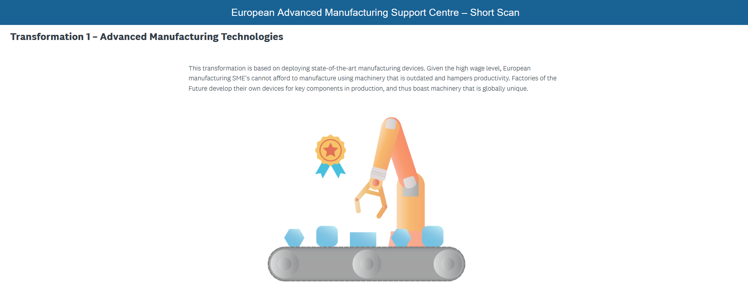
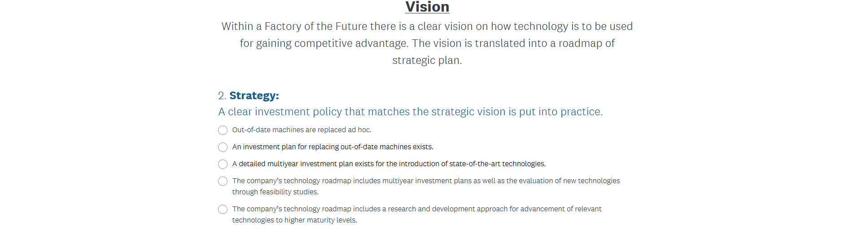
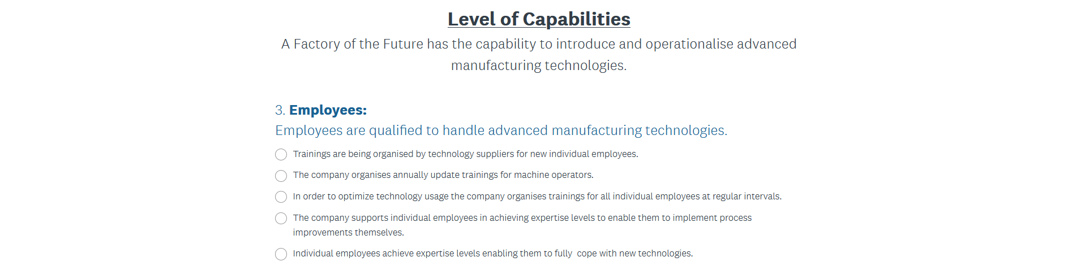
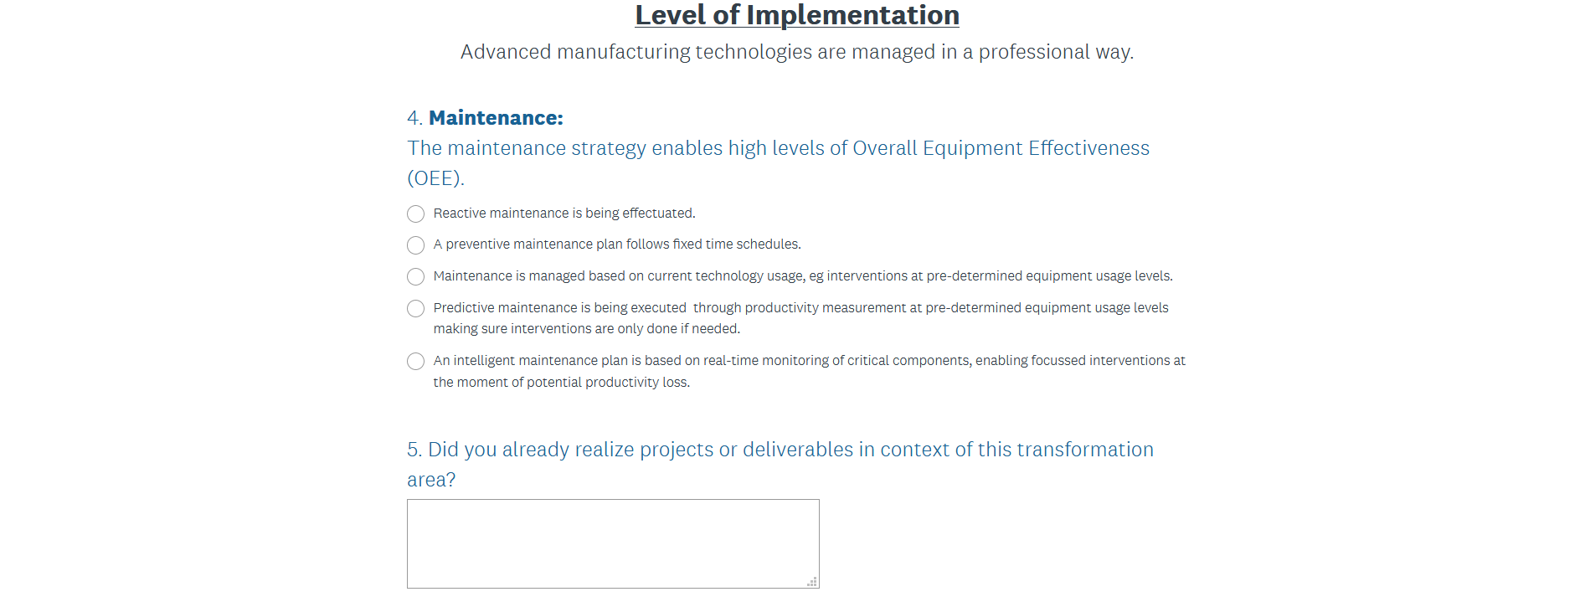

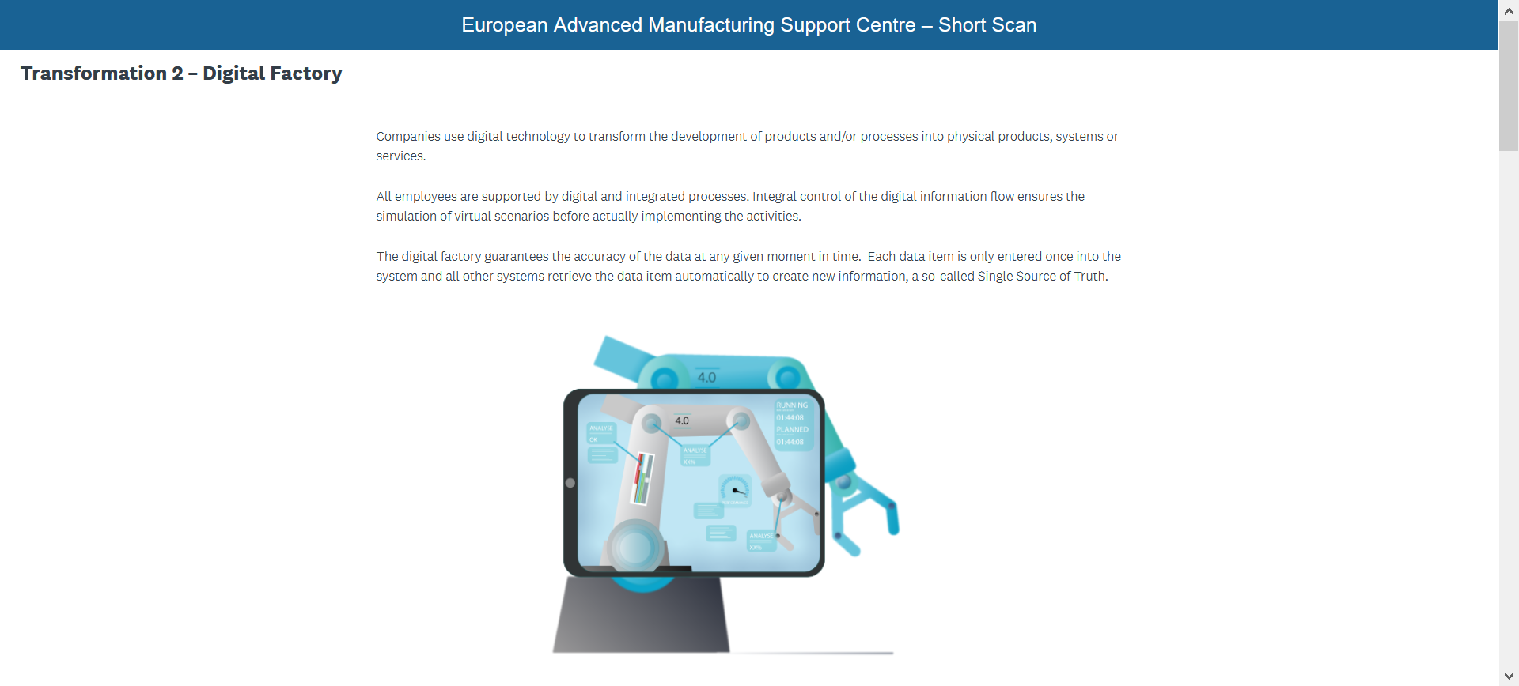
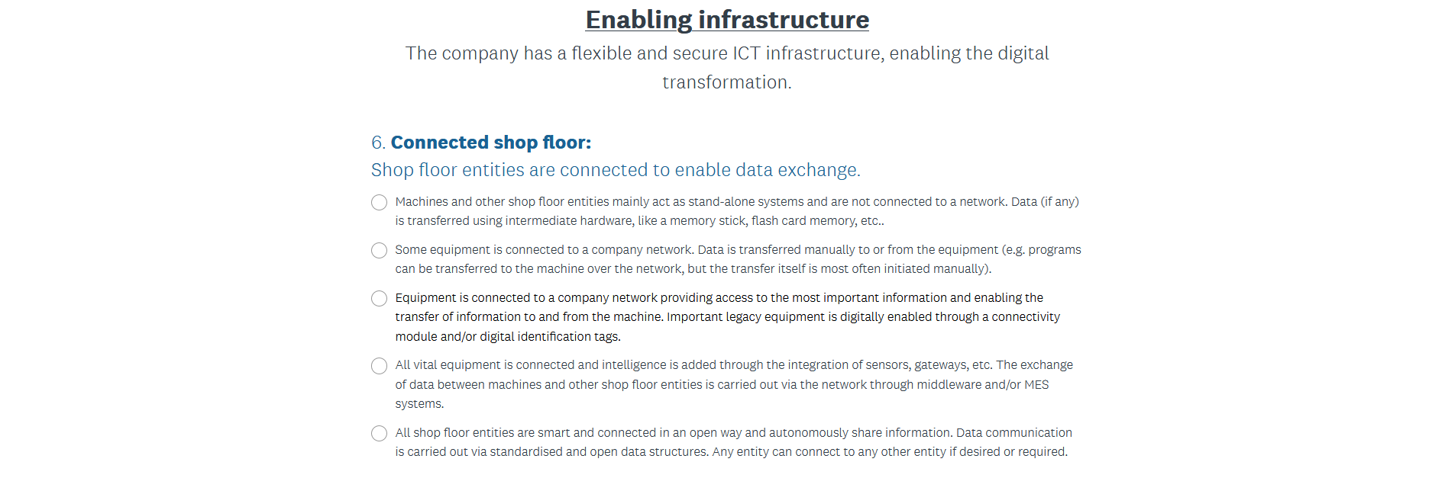
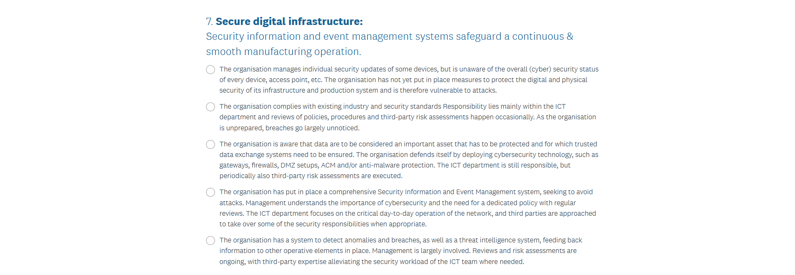
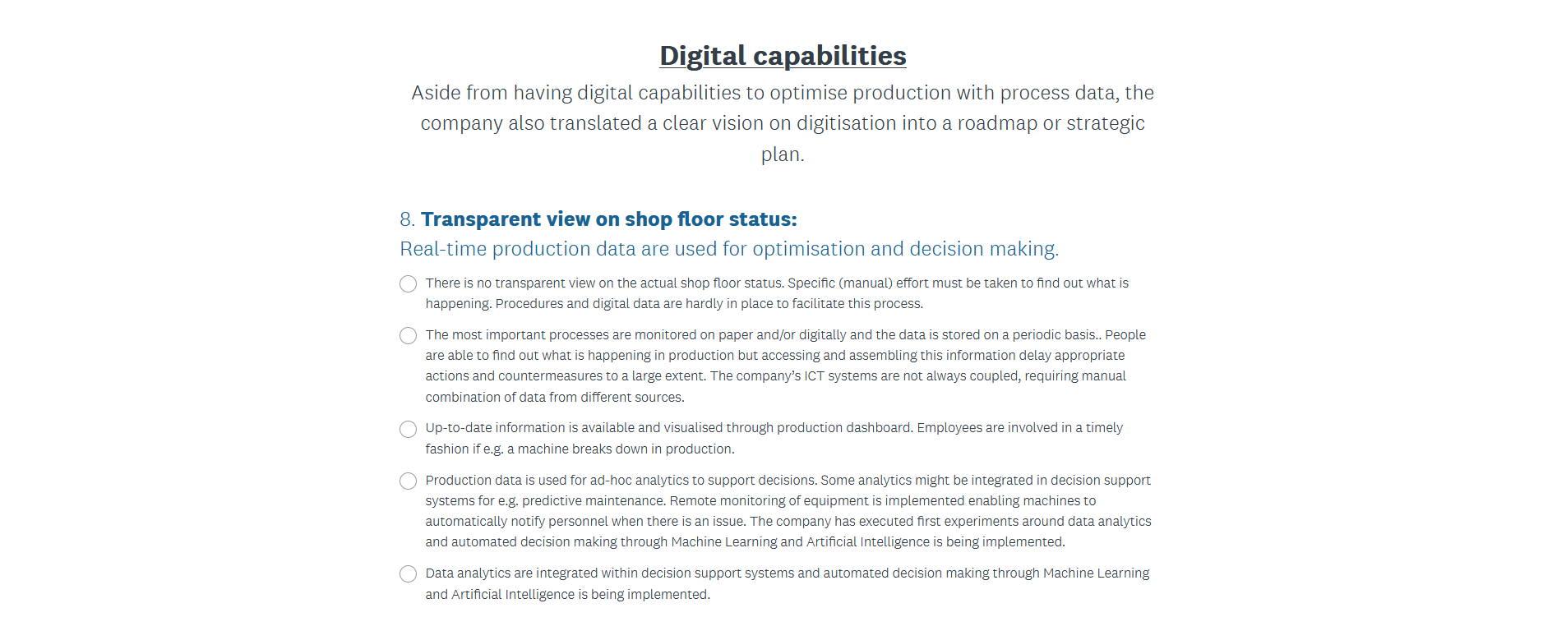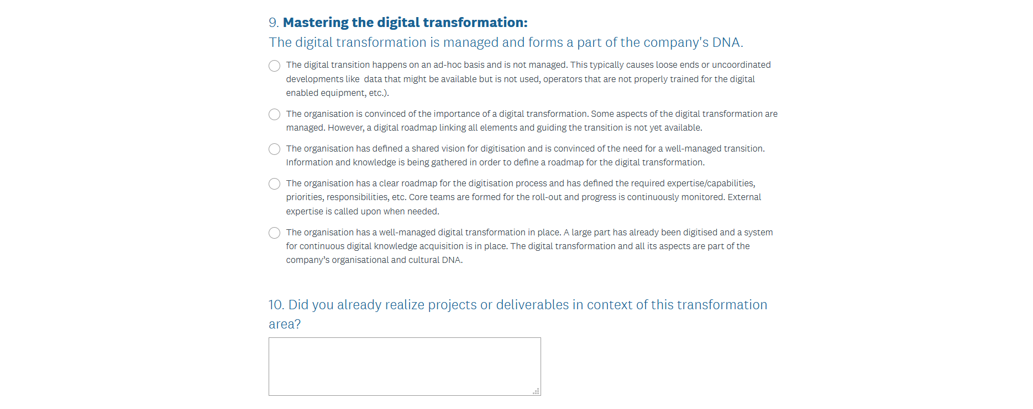

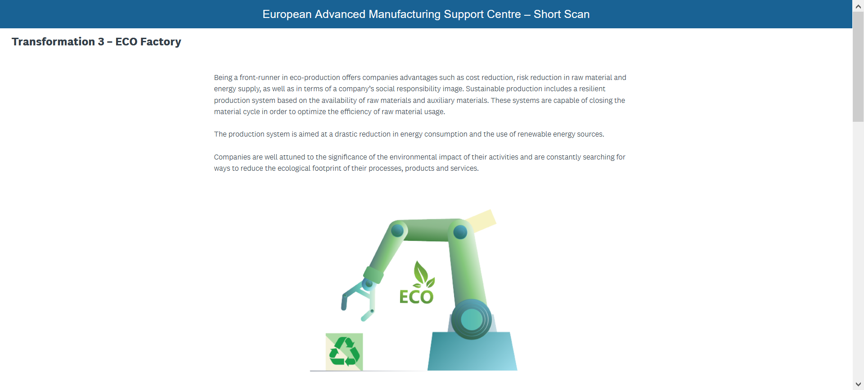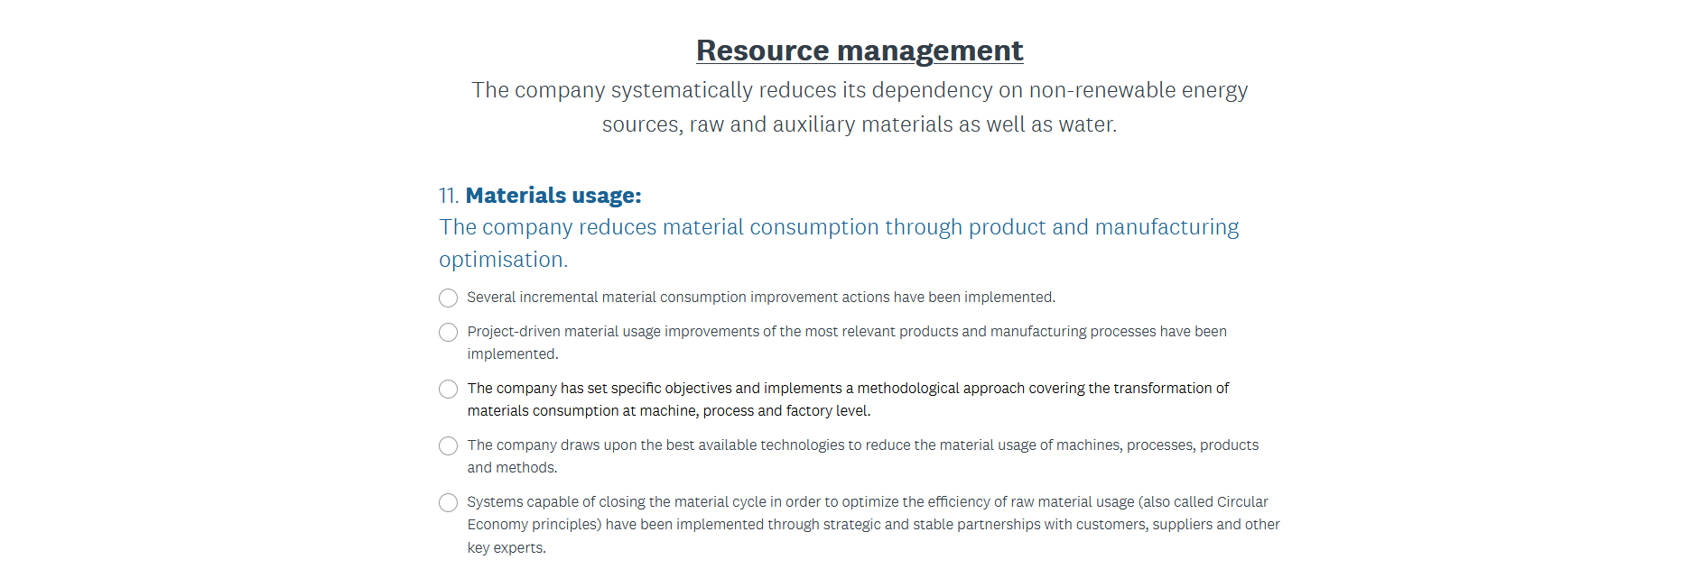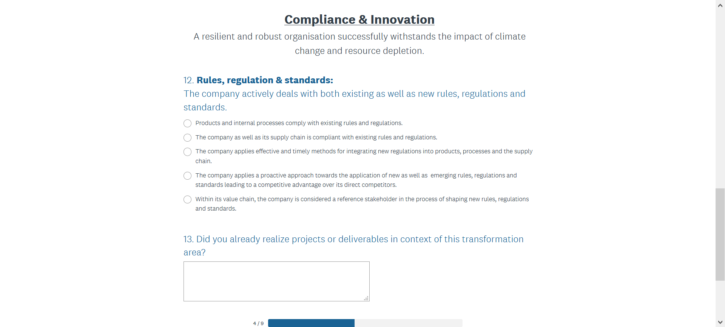
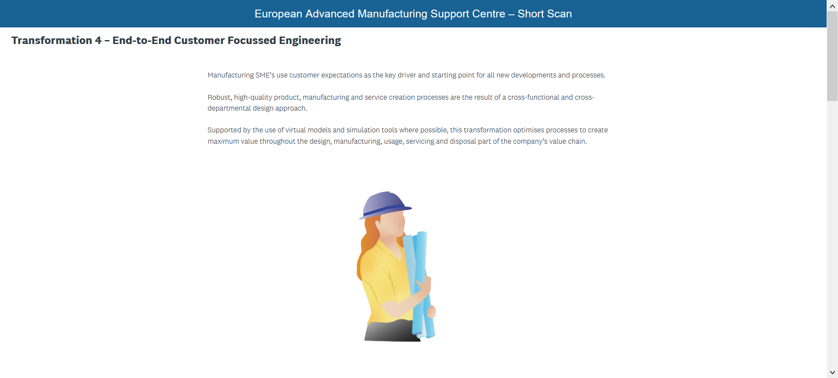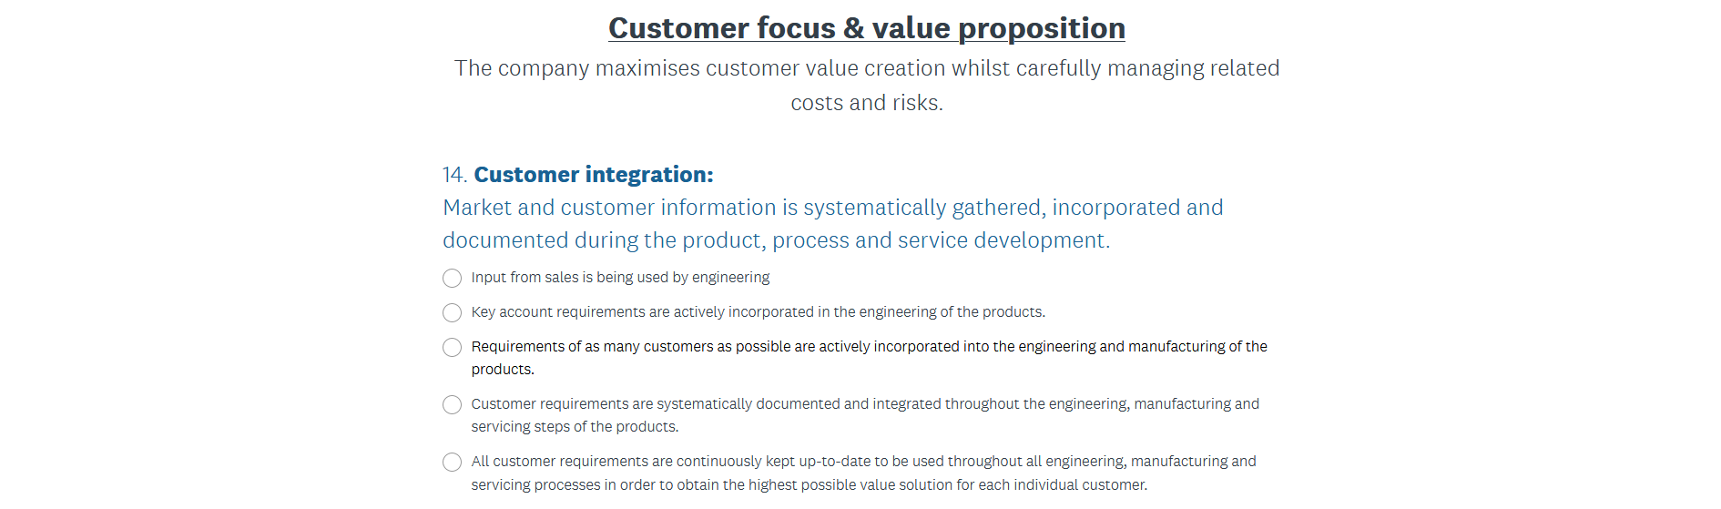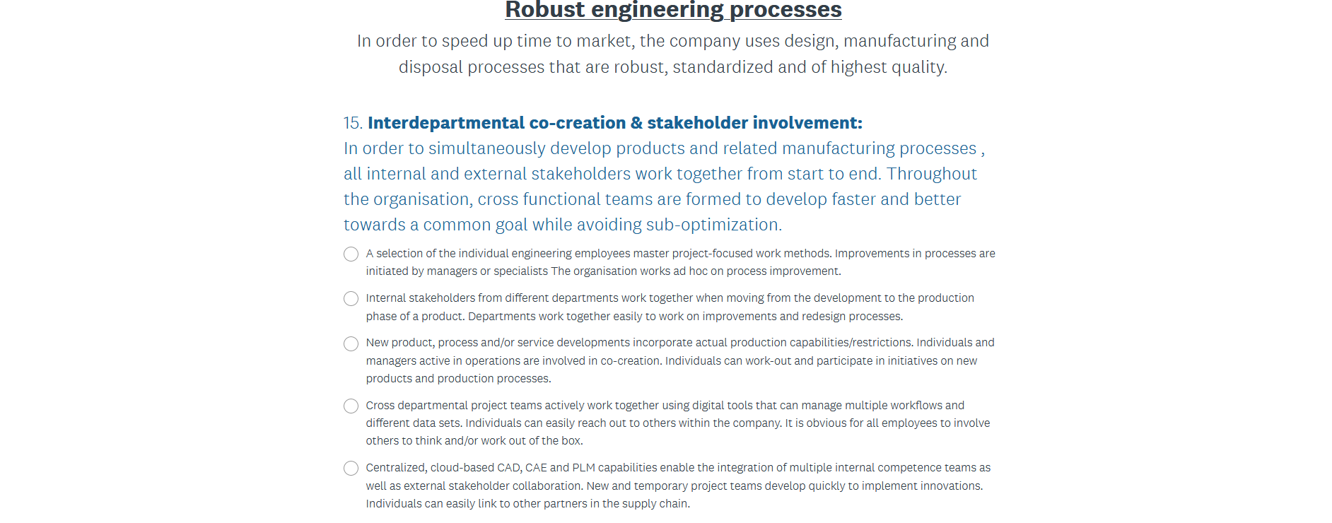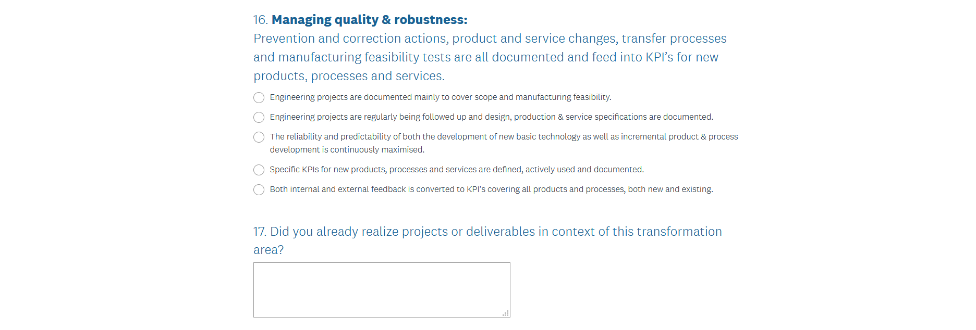

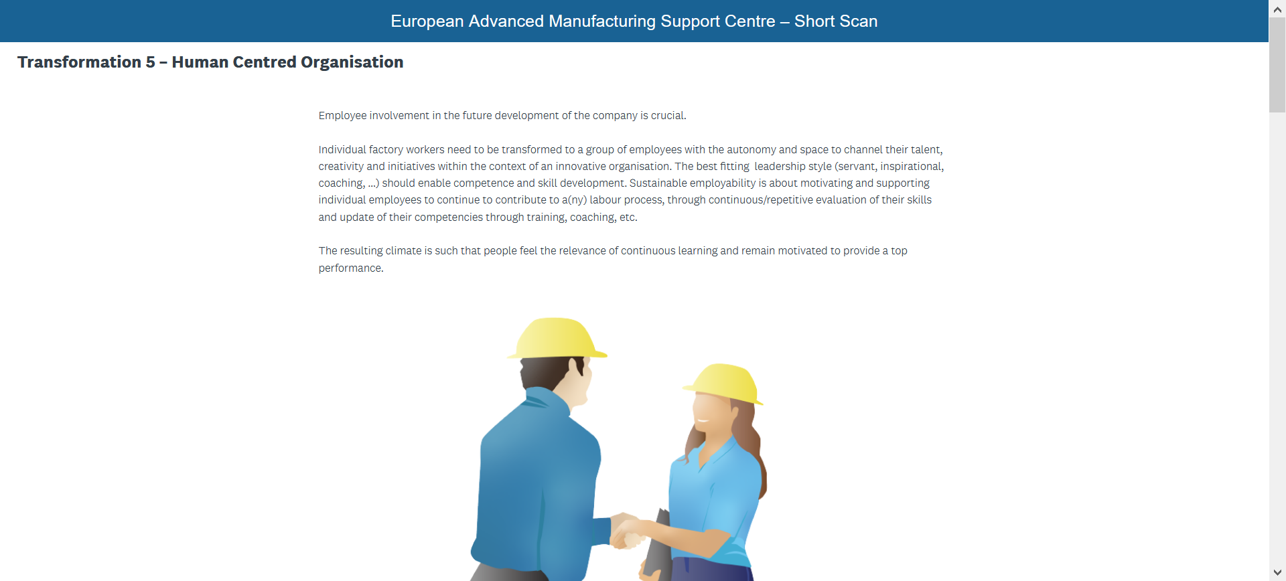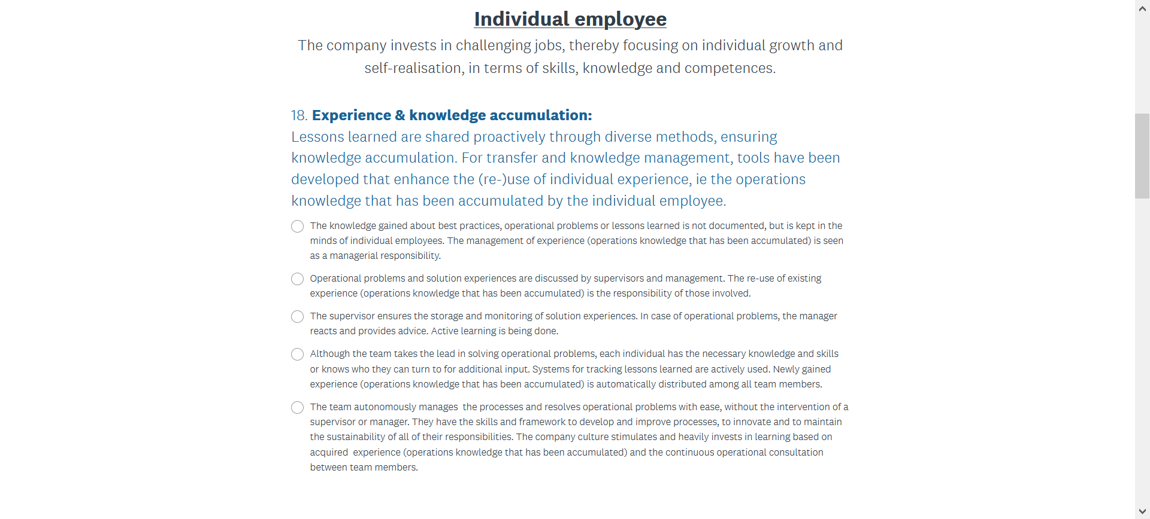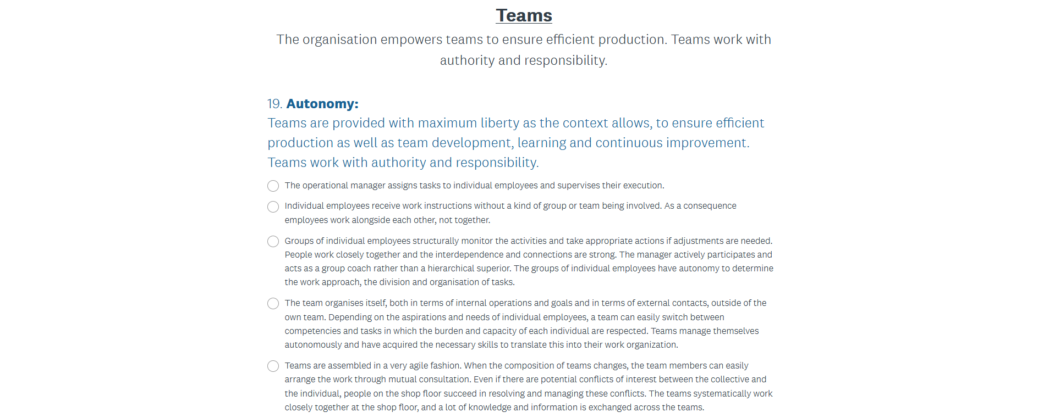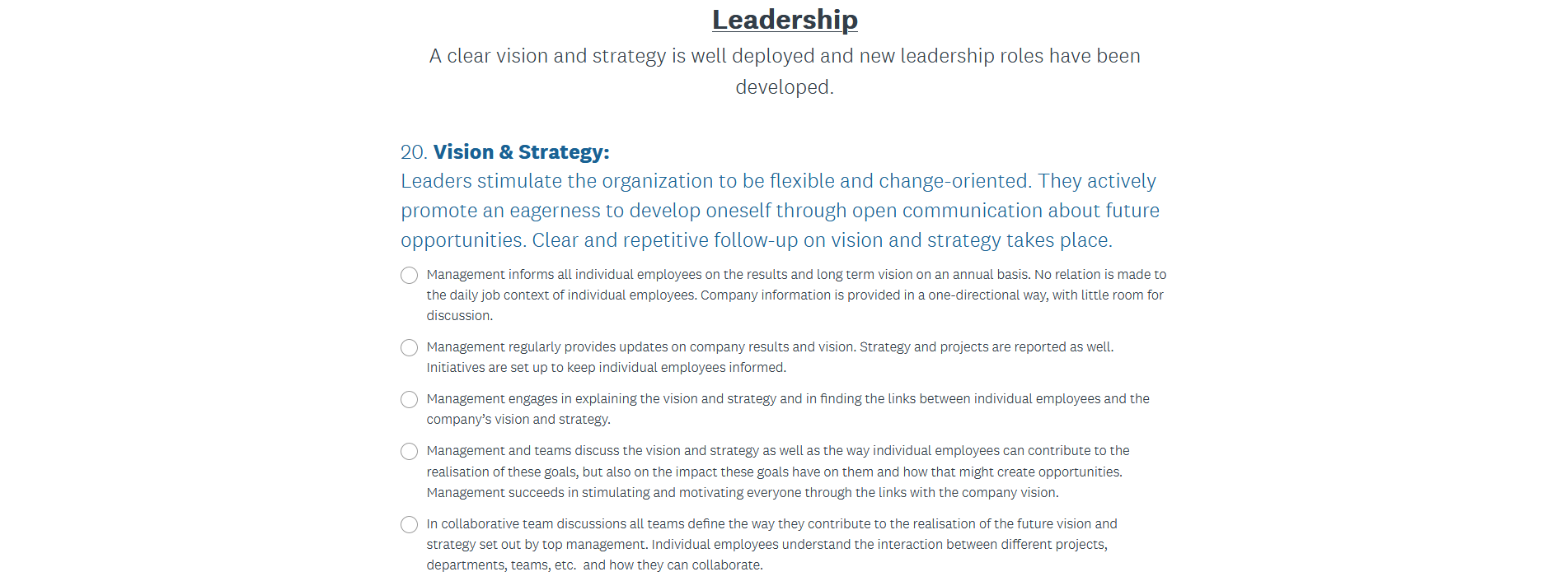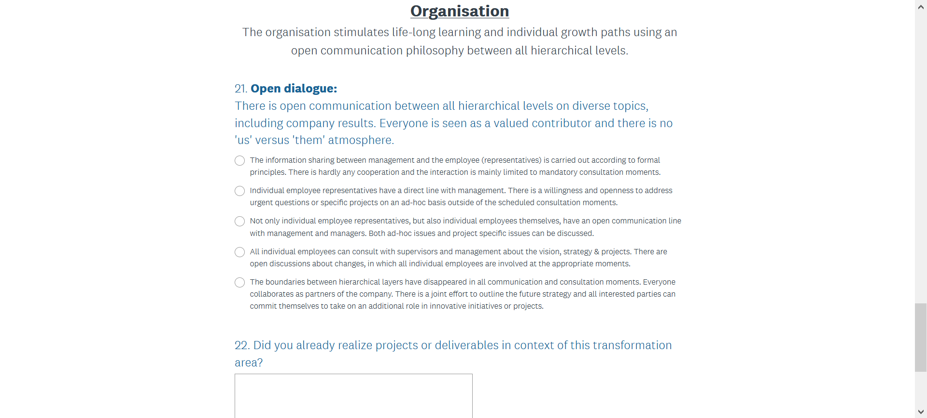

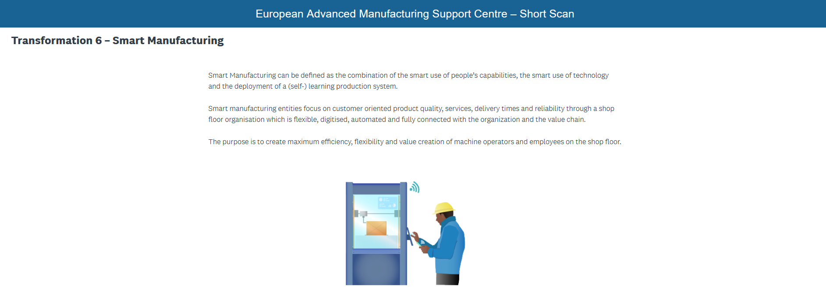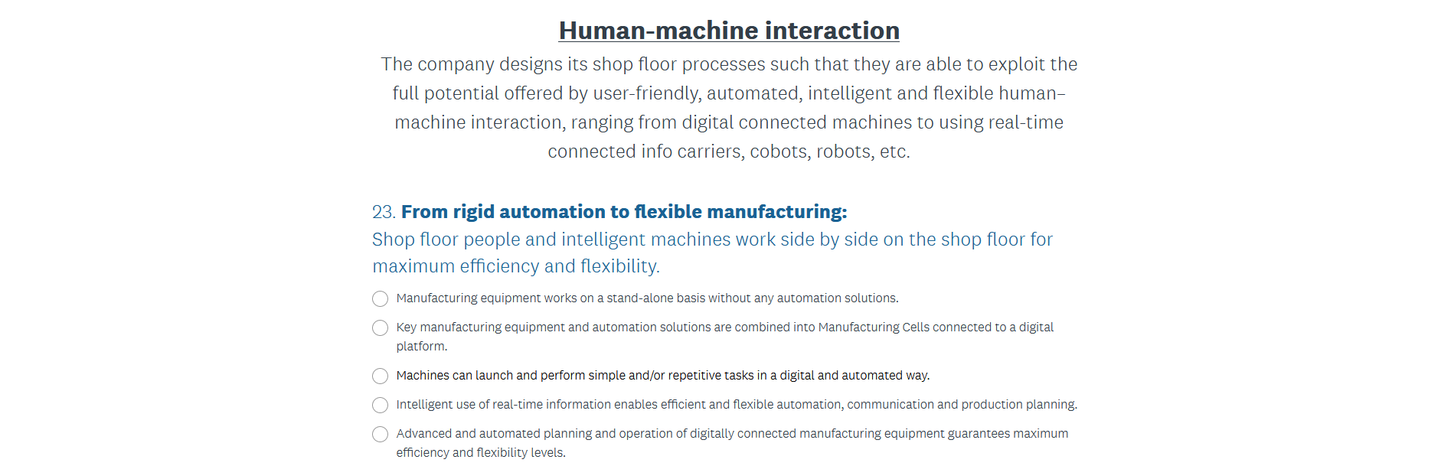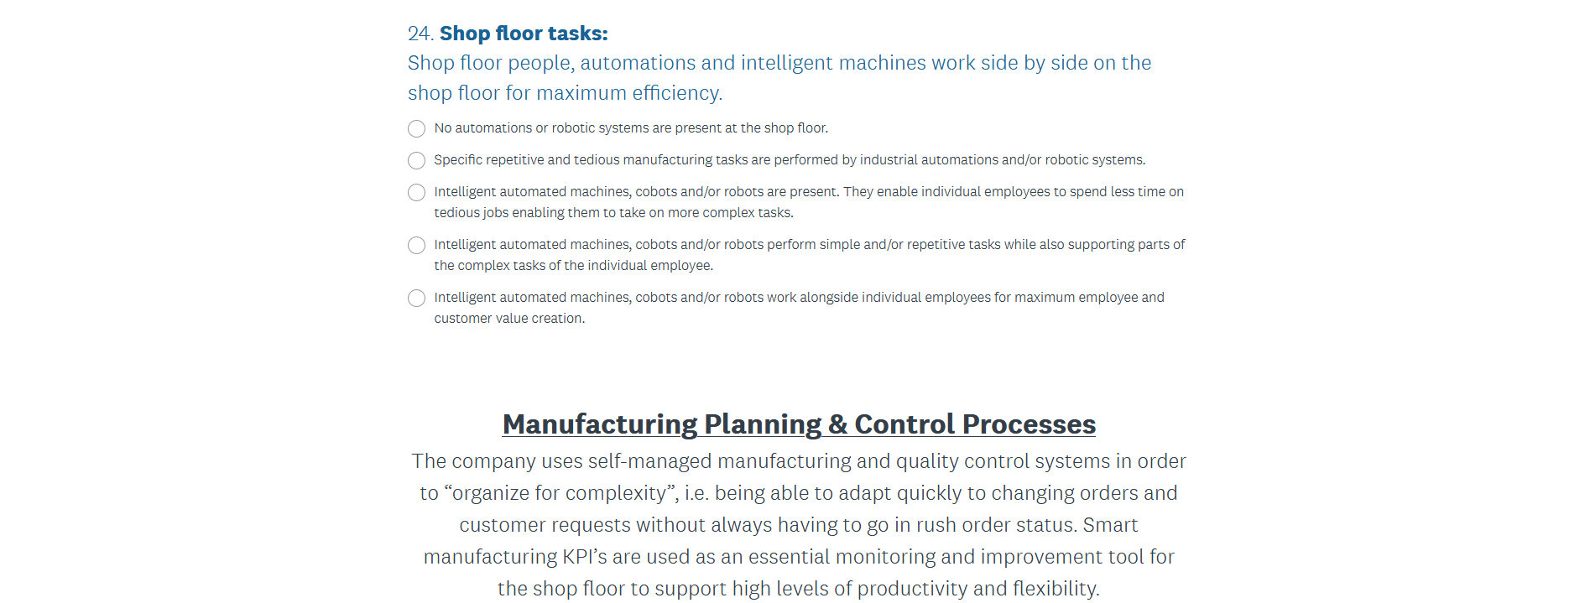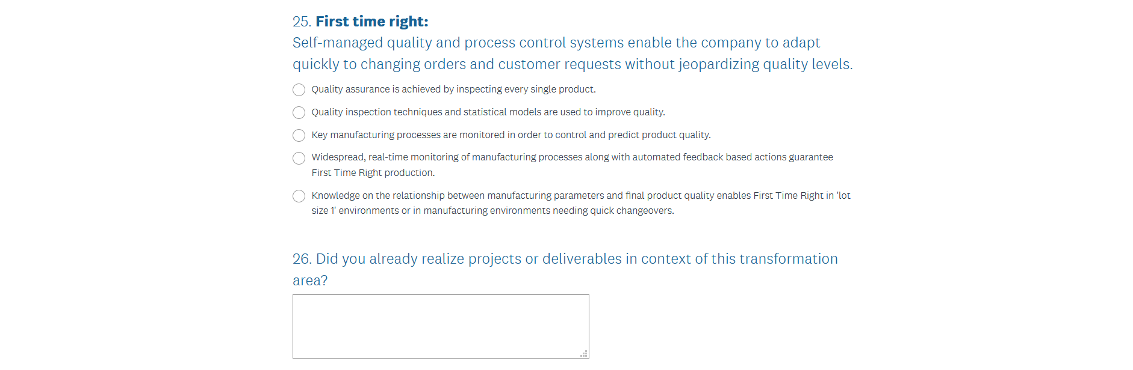

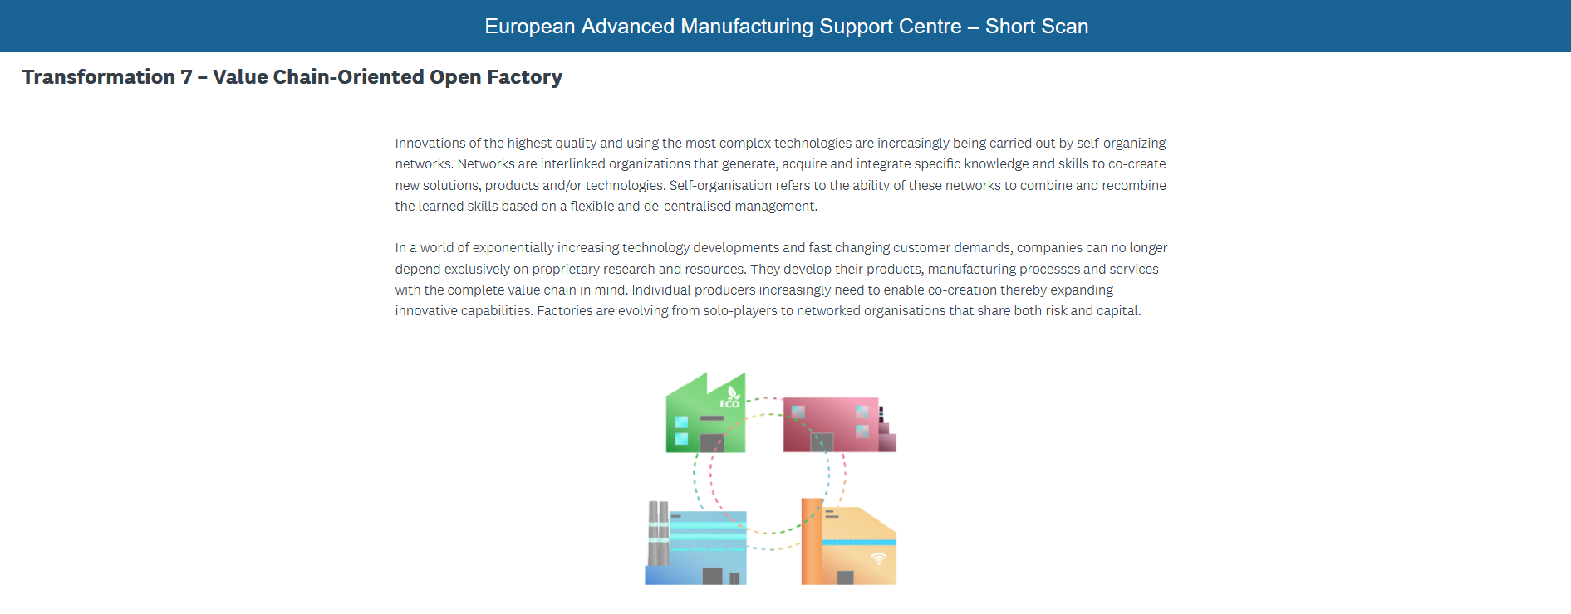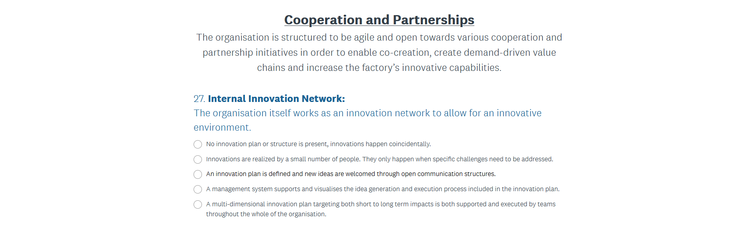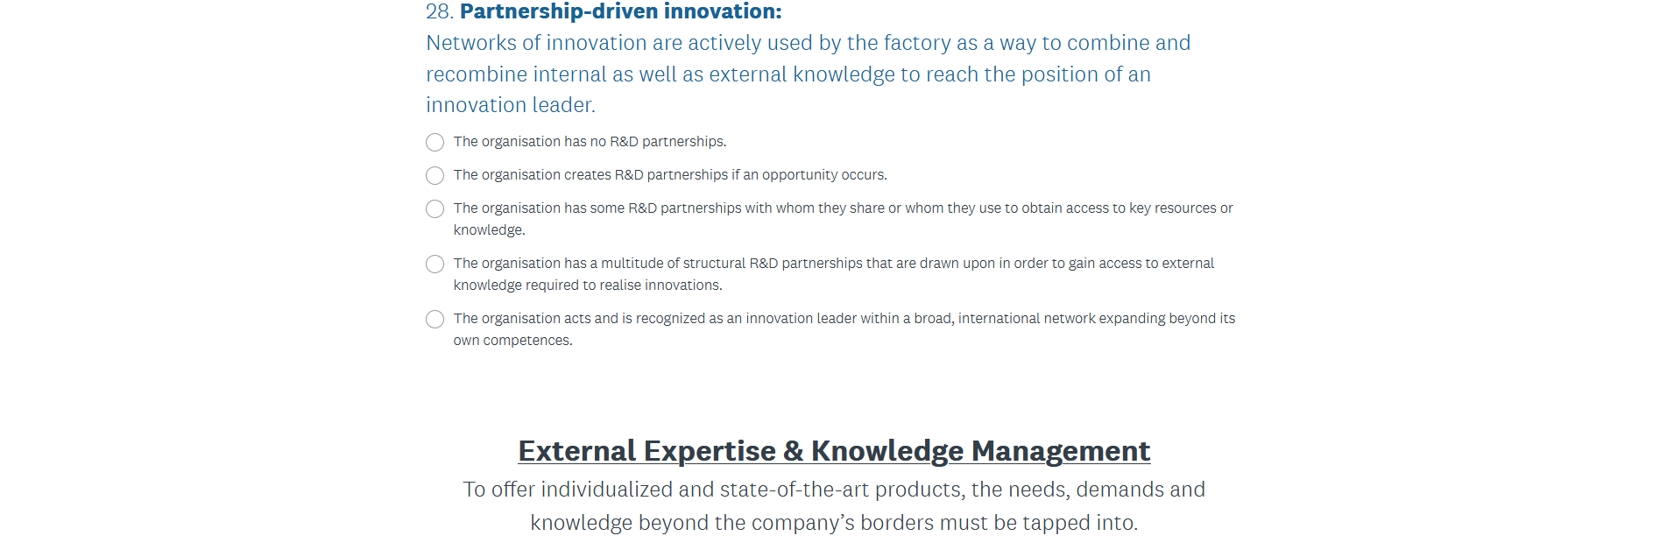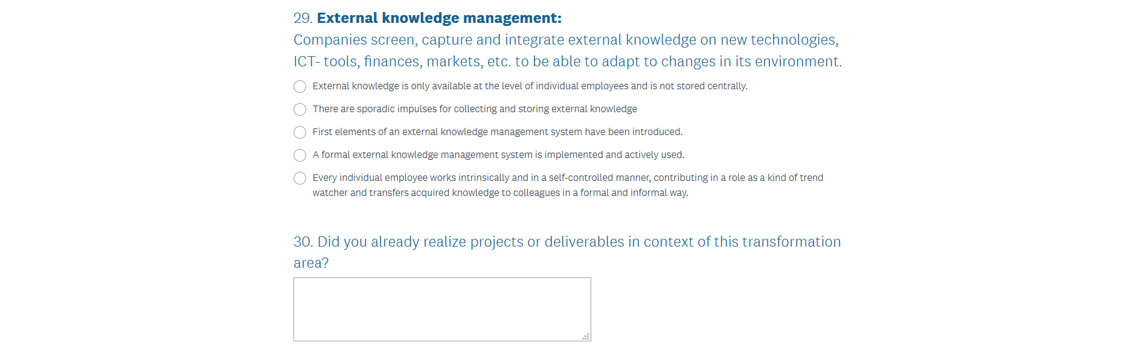
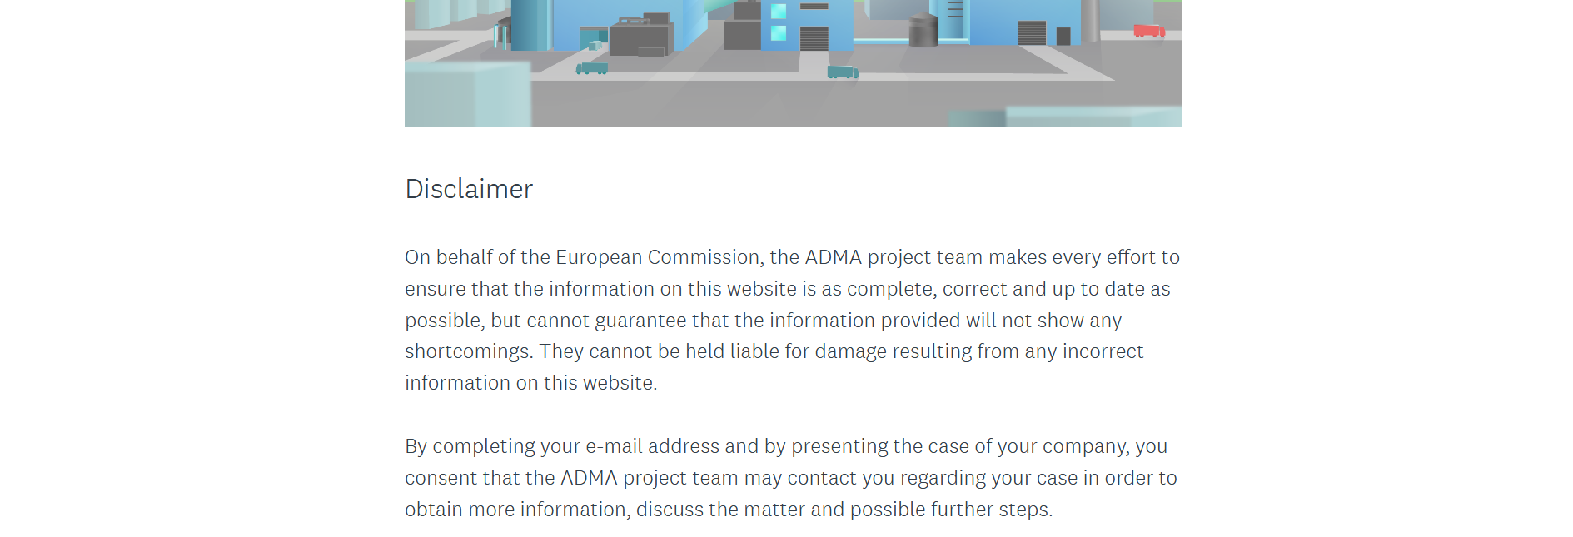
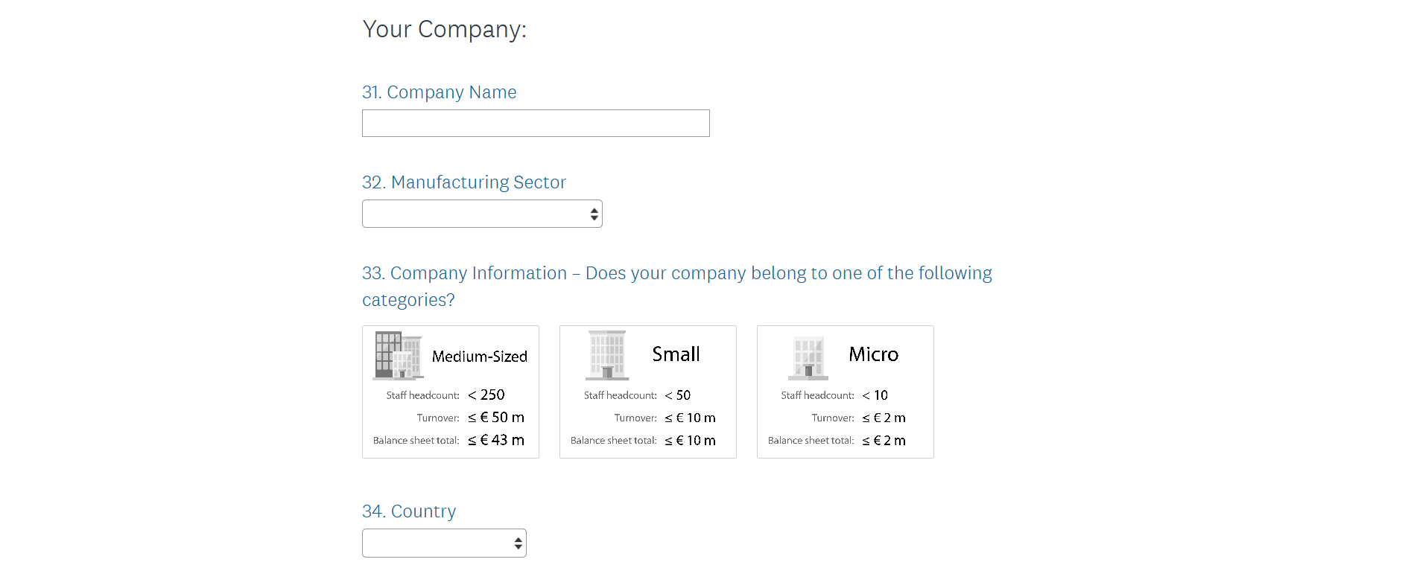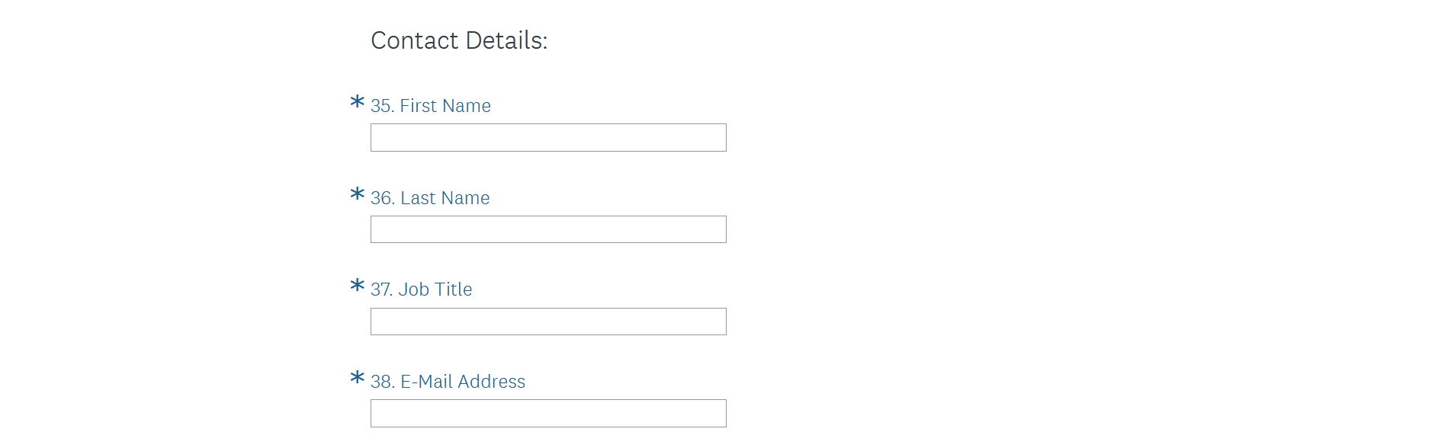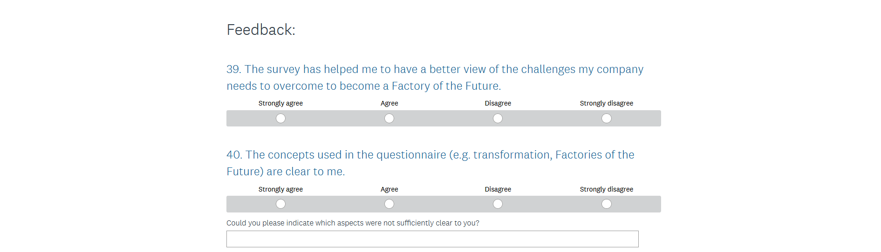

BIFOCALPS
 |  | Guidelines | 0 | 1 | 2 | 3 | 4
Strategy | G1.1 Company awareness | All stakeholders are aware of the benefits of the digital transformation
 | G1.2 Corporate culture | A new corporate culture is established in the company due to an intense communication strategy
 | G1.3 SWOT Analysis | The company has analysed its own strengths, weaknesses, opportunities and threats as to develop a suitable FoF-strategy
 | G1.4 Project management | The implementation of the FoF-transition is controlled intensively by clear project management (defining priorities, duration, milestones, budget, risks, …)
 | G1.5 Planning | Our changes towards FoF are planned and performed in small, incremental changes
 | G1.6 Business model | Our current and future business models are analysed deeply
 | G1.7 Product vs. Process | Our FoF-strategy is defined for both products and processes
 |  | Guidelines | 0 | 1 | 2 | 3 | 4
Technology | G2.1 Understanding technologies | Digital technologies are understood deeply regarding their TRL and reliability
 | G2.2 Technology assessment | A transparent and structured selection procedure of FoF-technologies is established in the company to secure the correct choice of investments
 | G2.3 Future-proof | The evolutionary aspect of the FoF-topic is understood and the company is not affected by the „hype“
 | G2.4 IT infrastructure | The IT infrastructure is ready to support FoF-technologies and guarantee the safety of data
 | G2.5 Clear process | The process of implementing FoF-technologies is clearly defined and considers pilot projects before deploying them to greater ones
 |  | Guidelines | 0 | 1 | 2 | 3 | 4
Capacity for innovation | G3.1 R&D&I activities | We are supporting the implementation of FoF practices by internal R&D&I activities
 | G3.2 Responsibilities | We have a strong and dedicated R&D&I-department
 | G3.3 Idea management | We foster creativity to boost innovation by a strong idea management and entrepreneurship among employees
 | G3.4 External collaborations | We have strong collaborations with other industrial companies and academic/research centres in the field of FoF
 | G3.5 Customer integration | We strongly integrate the customer in our digital transformation plan in order to fulfil their needs
 |  | Guidelines | 0 | 1 | 2 | 3 | 4
Ecosystems support for innovation | G4.1 Industry networks | We are strongly involved in professional industry networks in order to benefit from cross-sectoral fertilization
 | G4.2 Facilities | We collaborate steadily with research and technical centres in order to benefit from facilities and the latest innovation technologies and processes
 | G4.3 University collaboration | We actively collaborate with universities in order to keep informed about FoF-oriented training and identify new talents
 | G4.4 Public programs | We often participate in FoF-oriented public programs
 |  | Guidelines | 0 | 1 | 2 | 3 | 4
Skills and  change management | G5.2 Qualification structure | We invest in new highly qualified employees in order to successfully implement and manage new ICT-based solutions
 | G5.3 Training programs | We provide training programs for our employees in order to develop the required skills
 | G5.4 Open mind-set | The mind-set of our employees is open-minded to the path towards FoF
 | G5.5 Responsibilities | A change leader/department to manage the digital transformation in the company is defined

An industry 4 readiness assessment tool (I4ready)
For each row below indicate current readiness & 5 year ambition.
Products and services
Readiness level | Level 1  Beginner | Level 2  Intermediate | Level 3  Experienced | Level 4  Expert | Don't know | Not relevant
Product customisation | Product allows for no individualisation, standardised mass production | Majority of products are made in large batch sizes with limited late differentiation | Products can be largely customised but still have standardised base | Late differentiation available for most make-to-order products (batch size 1) | Don't know | Not relevant
Digital features of products | Products show only physical value | Products show value only from intellectual property licensing | Products exhibit some digital features and value from intellectual property licensing | Products exhibit high digital features and value from intellectual property licensing | Don't know | Not relevant
Data-driven services | Data-driven services are offered without customer integration | Data-driven services are offered with little customer integration | Data-driven services are offered with customer integration | Data-driven services are fully integrated with the customer | Don't know | Not relevant
Level of product data usage | Data is not used | 0-20% of collected data is used | 20-50% of collected data is used | More than 50% of collected data is used | Don't know | Not relevant
Share of revenue | Data-driven services account for an initial share of revenue (<2.5%) | Data-driven services account for a moderate share of revenue (2.5-7.5%) | Data-driven services account for a significant share of revenue (7.5-10%) | Data-driven services play an important role in revenue (>10%) | Don't know | Not relevant

Manufacturing and operation
Readiness level | Level 1  Beginner | Level 2  Intermediate | Level 3  Experienced | Level 4  Expert | Don't know | Not relevant
Automation | Few machines can be controlled through automation | Some machines and system infrastructures can be controlled through automation | Most machines and system infrastructures can be controlled through automation | Machines and systems can be controlled completely through automation | Don't know | Not relevant
Machine and operation system integration (M2M) | Machines and systems have no M2M capability | Machines and systems are to some extent interoperable | Machines and systems are partially integrated | Machines and systems are fully integrated | Don't know | Not relevant
Equipment readiness for Industry 4 | Significant overhaul required to meet Industry 4 model | Some machines and systems can be upgraded | Machines already meet some of the requirements and can be upgraded where required | Machines and systems already meet all future requirements | Don't know | Not relevant
Autonomously guided workpieces | Autonomously guided workpieces are not in use | Autonomously guided workpieces are not in use, but there are pilots underway | Autonomously guided workpieces used in select-ed areas | Autonomously guided workpieces are widely adopted | Don't know | Not relevant
Self-optimising processes | Self-optimisation processes are not in use | Self-optimising processes are not in use, but there are pilots in more advanced areas of the business | Self-optimising processes are used in selected areas | Self-optimising processes are widely used | Don't know | Not relevant
Digital modelling | No digital modelling | Some processes use digital modelling | Most processes use digital modelling | Complete digital modelling used for all relevant processes | Don't know | Not relevant
Operations data collection | Data is collected manually when required, e.g. sampling for quality control | Required data is collected digitally in certain areas | Comprehensive digital data collection in multiple areas | Comprehensive automated digital data collection across the entire process | Don't know | Not relevant
Operations data usage | Data is only used for quality and regulatory purposes | Some data is used to control processes | Some data is used to control and optimise processes, e.g. predictive maintenance | All data is used not only to optimise processes, but also for decision making | Don't know | Not relevant
Cloud solution usage | Cloud solutions not in use | Initial solutions planned for cloud-based software, data storage and data analysis | Pilot solutions implemented in some areas of the business | Multiple solutions implemented across the business | Don't know | Not relevant
IT and data security | IT security solutions are planned | IT security solutions have been partially implemented | Comprehensive IT security solutions have been implemented with plans developed to close any gaps | IT security solutions have been implemented for all relevant areas and are reviewed frequently to ensure compliance | Don't know | Not relevant
Strategy and organization
Readiness level | Level 1  Beginner | Level 2  Intermediate | Level 3  Experienced | Level 4  Expert | Don't know | Not relevant
Degree of strategy implementation | Industry 4 is recognised at departmental level but is not integrated into the strategy | Industry 4 is included in the business strategy | Industry 4 strategy has been communicated to the business and is widely understood | Industry 4 strategy has been implemented across the business | Don't know | Not relevant
Measurement | KPIs are not focused around Industry 4 | Structured set of business metrics exist, with some measurement of Industry 4 drivers | Industry 4 metrics are widely understood in the business and used in monthly reporting | Business metrics and personal development plans are focused around Industry 4 objectives | Don't know | Not relevant
Investments | Initial Industry 4 investments in one business area | Industry 4 investments in more advanced business areas | Industry 4 investments in multiple business areas | Industry 4 investments across the entire business | Don't know | Not relevant
People capabilities | Employees have little or no experience with digital technologies | Technology focused areas of the business have employees with some digital skills | Developed digital and data analysis skills across most areas of the business, e.g. production | Leading edge digital and analytics skills across the business | Don't know | Not relevant
Collaboration | The business operates in functional silos | There is limited interaction between departments, e.g. S&OP process | Departments are open to cross functional collaboration | Departments are open to cross company collaboration to drive improvements | Don't know | Not relevant
Leadership | Leadership team do not recognise the value of Industry 4 investments | Leadership team are investigating potential Industry 4 benefits | Leadership team recognise the financial benefits to be obtained through Industry 4 and are developing plans to invest | Widespread support for Industry 4 within both the leadership team and across the wider business | Don't know | Not relevant
Finance | No sizeable Industry 4 investment | No ongoing review of cost/benefit analysis for Industry 4 investment | Annual cost/benefit analysis of Industry 4 investment | Quarterly cost/benefit analysis of Industry 4 investment | Don't know | Not relevant

Supply chain
Readiness level | Level 1  Beginner | Level 2  Intermediate | Level 3  Experienced | Level 4  Expert | Don't know | Not relevant
Inventory control using real-time data management | Inventory levels are understood | Computer database is used which is manually updated with inventory levels | Computer database used with smart devices updating inventory levels | Real-time database which is updated by smart devices | Don't know | Not relevant
Supply chain integration | Ad hoc reactive communication with suppliers and customers | Basic communication and data sharing where required with suppliers and customers | Data transfer between key strategic suppliers/customers (e.g. customer inventory levels) | Fully integrated systems with suppliers/customers for appropriate processes (e.g. real-time integrated planning | Don't know | Not relevant
Supply chain visibility | No integration with suppliers or customers | Site location, capacity, inventory and operations are visible between first tier suppliers and customers | Site location, capacity, inventory and operations are visible throughout supply chain | Site location, capacity, inventory and operations are visible in real-time throughout supply chain and used for monitoring and optimisation | Don't know | Not relevant
Supply chain flexibility | Slow response to market changes | Moderate response to market changes and general customer requirements shifts | Moderate response to changes in market environment and individual customer requirements | Immediate response to changes in market environment and individual customer requirements | Don't know | Not relevant
Lead times | Long materials lead time resulting in high inventory levels | Improvements have been identified to reduce lead times for some materials | Some improvements have been implemented to reduce lead times on key materials | Differentiated stocking policies and lead times to meet make-to-order efficiently | Don't know | Not relevant

Business model
Readiness level | Level 1  Beginner | Level 2  Intermediate | Level 3  Experienced | Level 4  Expert | Don't know | Not relevant
As a service business model | No awareness | Aware of concept with some initial plans for development | High awareness and implementation plans are in development | As a service has been implemented and is being offered to the customer | Don't know | Not relevant
Data driven decisions | Data is not widely analysed | Some data is analysed and features in key business reports to review performance | Most data is analysed and the result is considered when making business decisions | All relevant data is analysed and informs business decisions | Don't know | Not relevant
Real-time tracking | Limited product tracking | Product can be tracked as it moves between manufacturing and internal distribution sites | Product can be tracked through manufacturing and distribution until it reaches the customers distribution centre | Product can be tracked along the complete lifecycle | Don't know | Not relevant
Real-time and automated scheduling | Equipment is manually maintained in line with the maintenance schedule | Some machines alert operators of a performance issue which enables them to manually schedule a maintenance task | Some machines are self-diagnosing, automatically passing information to the maintenance scheduling system | Machines are generally self-diagnosing and the maintenance schedule adjusts itself based on real time data inputs from the machine | Don't know | Not relevant
Integrated marketing channels | Online presence is separated from offline channels | Integration within the online and offline channels but not between them | Integrated channels and individualised customer approach | Integrated customer experience management across all channels | Don't know | Not relevant
IT supported business | Main business process supported by IT systems | Some areas of the business are supported by IT systems and integrated | Complete IT support of processes but not fully integrated | IT systems support all company processes and are integrated | Don't know | Not relevant

Legal considerations
Readiness level | Level 1  Beginner | Level 2  Intermediate | Level 3  Experienced | Level 4  Expert | Don't know | Not relevant
Contracting models | Contracting processes are linear and unchanged | Some changes to contracting processes to reflect operational changes | Some 'flagship' projects utilise new contracting models but it is not standard across the board | All contracting is behavioural and incentivises all parties to achieve the best result | Don't know | Not relevant
Risk | New risks not identified or assessed | New risks identified and/or assessed but no mitigations planned | New risks identified and assessed, and limited mitigations put in place | Working party has assessed the changing risk profile and has procedures in place to mitigate these | Don't know | Not relevant
Data protection | No data protection policies or procedures | Have internal policies but do not ensure compliance in engagement with suppliers/customers | Good understanding with robust policies and procedures but haven't updated for General Data Protection Regulation | Conducted a recent General Data Protection Regulation audit and are confident of compliance including in light of Industry 4 | Don't know | Not relevant
Intellectual property | Intellectual property in new products and services is not identified or protected | Awareness of intellectual property in new products and services, but no legal protections identified or applied for | Intellectual property in products and services is identified and in part assessments made as to whether registrations/contractual rights required, and if required, appropriate steps taken | Intellectual property in products and services is identified and assessments made as to whether registrations/contractual rights required and, if required, appropriate steps taken | Don't know | Not relevant

The Industry 4.0 / Digital Operations Self Assessment
Actual (current state), Target (within 5 years)
Business Models, Product & Service Portfolio
 | Actual | Target | Explanation
How would you rate the contribution of digital features, products & services to the overall value creation of your portfolio? | 1-5 | 1-5 | 5: Main contribution - Value is mainly generated by purely digital products and the licensing of Intellectual Property (e. g. cloud-based predictive maintenance solution, licenses for 3D-printing of products)  1: No contribution - Value is generated solely with the sales of physical products and product-related services (e.g. traditional maintenance)
To which degree is the average product in your portfolio digitized (e.g. RFID for identification, sensors, IoT connection, smart products etc.)? | 1-5 | 1-5 | 5: Completely - Digital services are at the core of the portfolio, physical products are mainly used as mediums (e.g. “app store” for additional machine configurations and features)  1: Not at all - Portfolio is focused on purely physical products (e.g. mechanical machines without digital feature or network connections etc.)
To which degree can your customers individualize the products they order? | 1-5 | 1-5 | 5: Completely - Products can be completely defined by customers (e.g. via configuration tools for customers, lot size 1)  1: Not at all - Products allow for no individualization at all (e.g. standardized mass production)
To which degree are the life cycle phases of your products digitized (digitization and integration of design, planning, engineering, production, services & recycling)? | 1-5 | 1-5 | 5: Complete digitization & integration - All phases in the product life cycle are completely digitized (e.g. producibility can directly be tested during product development via virtual prototyping)  1: Low level of digitization & integration - Isolated IT enablement of different steps in product life cycle (e.g no integration of engineering and production)
How important is the usage and analysis of data (customer data, product or machine generated data) for your business model? | 1-5 | 1-5 | 5: Crucial - Data is the main value driver of the business model (e.g. data on machine capacity utilization is used to determine the amount of fees)  1: Insignificant - No data analytics are leveraged in the business model
How intense is your collaboration with partners, suppliers and clients for development of products and services? | 1-5 | 1-5 | 5: Intense collaboration - Collaborative development of products together with partners is institutionalized in value networks that are transparent for the customers  1: No Collaboration - Product development is done completely in-house without any exchange of information with partners, suppliers or customers
How intense is your collaboration with partners, suppliers and clients for development of products and services? | 1-5 | 1-5 | 5: Intense collaboration - Collaborative development of products together with partners is institutionalized in value networks that are transparent for the customers  1: No Collaboration - Product development is done completely in-house without any exchange of information with partners, suppliers or customers
Market & Customer Access
 | Actual | Target | Explanation
To which extent do you use multiple integrated sales channels to sell your products to your customers? | 1-5 | 1-5 | 5: Multi/ Omni-Channel – Integration of various digital and non-digital sales channels (e.g. store, sales force, web-shop, sales platforms etc.)  1: One channel - Traditional sales force approach (e.g. local sales force)
How far do you integrate multiple channels (website, blogs, forums, social media platforms etc.) into your customer interactions for communicating news, receiving feedback, managing claims etc.? | 1-5 | 1-5 | 5: Interactive communication – Usage of multiple digital channels to foster customer interaction (e.g. integrating customers into product development via social media platforms)  1: One-way communication – Usage of traditional communication channels for information purposes only (e.g. corporate website, newsletters)
How advanced is the digital enablement of your sales force (mobile devices, access to all relevant system anywhere and anytime, full sales process possible at client site)? | 1-5 | 1-5 | 5: Digital sales approach - Sales force is supported by digital devices and access to all relevant processes and systems at any time (real-time access to customer and product data, possibility to configure personalized products & dynamically create orders etc.)  1: Traditional sales approach - Sales force works ‘offline’ without access to relevant systems (e.g. using centrally distributed paper documents)
How dynamic and customer-tailored is your pricing system (consideration of customer's "willingness to pay“)? | 1-5 | 1-5 | 5: Dynamic pricing - Automated systems calculate prices, discounts etc. dynamically in real-time (e.g. individual prices based on customer potential, history, relevance of order etc.)  1: Fixed pricing - Prices for all products and services are fixed (e.g. price catalogues based on traditional market research)
To which extent do you analyze customer data to increase customer insight (e. g. personalized offers to customers based on their personal situation, preferences, location, credit score; consideration of usage data for design & engineering etc.)? | 1-5 | 1-5 | 5: Substantial data usage - Extensive data collection at all touch points that is fed into integrated systems to monitor, review and optimize products, sales and customer experience  1: Trivial data usage - Information is kept decentralized and in an unsystematic way by single units and is not analyzed further (e.g. sales orders in excel sheets)
How far do you collaborate with partners regarding your approach of accessing customers (exchange of customer insights, coordination of marketing activities etc.)? | 1-5 | 1-5 | 5: Unified approach – Customer access approach is completely backed up along with the partner network (e.g. common customer ID with partners and use of partner data)  1: Not at all - No collaboration with partners in approaching customers (e.g. separate customer databases and no coordination of marketing or sales activities)
Value Chains & Processes
 | Actual | Target | Explanation
How would you rate the degree of the digitization of your vertical value chain (from product development to production)? | 1-5 | 1-5 | 5: Complete digitization – Continuous data flow along the vertical value chain (e.g. direct controlling of machines via CAD models, integration of ERP and MES)  1: No digitization at all - No automated exchange of information along the vertical value chain (e.g. manual machine programming based on paper plans)
To which extent do you have a real-time view on your production and can dynamically react on changes in demand? | 1-5 | 1-5 | 5: Virtual Factory – Real-time view on production with capabilities to dynamically change schedules  1: Not at all – Batch production for large lot sizes without insight into production status. No ability to react flexible on changes in demand
To which degree do you have an end-to-end IT enabled planning and steering process from sales forecasting, over production to warehouse planning and logistics? | 1-5 | 1-5 | 5: Integrated end-to-end planning system – Comprising real-time information along the entire value chain (e.g. sales forecasts directly affect production)  1: Isolated planning processes – Neither IT-enabled nor integrated along the value chain (e.g. planning based on past experiences)
How advanced is the digitization of your production equipment (sensors, IoT connection; digital monitoring, control, optimization & automation)? | 1-5 | 1-5 | 5: Fully digitized factory – Interconnected production equipment allows for IT-access and information is fed into a virtual representation of the factory  1: Purely physical factory – Production equipment is entirely cut off from IT systems and no real-time information can be gathered
How would you rate the degree of digitization of your horizontal value chain (from customer order over supplier, production and logistic to service)? | 1-5 | 1-5 | 5: Complete digitization – Continuous data flow along the horizontal value chain (e.g. integration of logistic service providers into internal IT)  1: No digitization at all – No automated exchange of information along the horizontal value chain (e.g. no connection to supplier’s IT)
IT Architecture
 | Actual | Target | Explanation
To which extend does your IT architecture address the overall requirements from digitization and Industry 4.0? | 1-5 | 1-5 | 5: Completely – All relevant requirements are explicitly considered in the IT architecture, the roadmap reflects enhancements to meet future needs  1: Not at all – The current architecture neither considers I4.0 requirements (IoT, analysis of production data etc.) directly nor is it easily adaptable for the new requirements
To which extend do you use a manufacturing execution system (MES) or similar to control your manufacturing process? | 1-5 | 1-5 | 5: Extensively – MES or similar is used for short-term planning (capacities, utilization, schedules etc.), system is highly integrated with ERP and shop floor system to enable vertical integration1: Not at all – Production planning is done by hand without support of a central IT system
How mature is your IT & data architecture to gather, aggregate and interpret real-time manufacturing, product and client data? | 1-5 | 1-5 | 5: High maturity – Advanced (near) real-time analytic capabilities to service monitoring, controlling and optimizing manufacturing and smart devices  1: Low maturity - No central system for data analytics, analysis is done in island solutions if at all
How important are new technologies like social media, mobility, analytics and cloud computing for enabling business operations? | 1-5 | 1-5 | 5: Crucial - Exploration and exploitation of new digital technologies with the overall aim of enabling decisive business operations (e.g. social media, both internally and externally, tracking consumer moods online and building knowledge sharing platforms internally)  1: Insignificant – Only minor investments in new technologies that are vaguely linked to business strategy (e.g. social media presence because it is perceived as 'the thing to do‘)
To which extent is your IT organization able to fulfill business requirements in the requested time, quality and cost? | 1-5 | 1-5 | 5: Expectations are always met – The IT is able to react agile to new and changing requirements. Business and IT are perfectly aligned  1: Expectations fall regularly short – Implementation time and quality fail to meet business expectations (e.g. long lead times, inflexible IT processes etc.)
How advanced is your IT integration with customers, suppliers and fulfillment partners? | 1-5 | 1-5 | 5: Full integration – Interfaces for all relevant IT systems allowing seamless and secure data exchange (e.g. complete order tracking for customers, inventory insight for suppliers)1: No integration at all – Encapsulated IT systems allowing no access for external parties
Compliance, Legal, Risk, Security & Tax
 | Actual | Target | Explanation
How sophisticated is your digital compliance policy? | 1-5 | 1-5 | 5: Highly sophisticated – Digital compliance policy is defined for the complete organization and supported by a digital ICS  1: Lowly sophisticated – No dedicated compliance policy for digitization in place and processes of internal control are for the most part non-digital
To which extent can you ensure that intellectual property (IP) for your digital products and services is protected properly and you do not violate external IP? | 1-5 | 1-5 | 5: Guaranteed – Integrated processes have been established to ensure that IP is treated according to the regulatory framework  1: Not guaranteed – IP protection is done opportunistically on a case by case basis and external IP violation cannot be excluded
How far does your risk management consider your (digital) product portfolio and production/the factories? | 1-5 | 1-5 | 5: Extensive consideration – Risks accompanying the digitization of products and the production itself are completely addressed by risk management  1: No consideration – Risk management does not yet include (digital) production and the product portfolio
To which extent are digital components of your value chain managed with respect to tax related topics (location of IP etc.)? | 1-5 | 1-5 | 5: Completely – Special approach for digital assets, location and the set up for the digital property (licenses, patents, IP etc.) is handled in a tax optimized way  1: Not at all – Same approach as for physical assets in place, digital IP is handled opportunistically
To which extent is your production considered within your (IT) security concept? | 1-5 | 1-5 | 5: Completely – Production is completely integrated into the security concept and respective mechanisms are implemented to protect production from cyber threads, interaction of security and safety is considered  1: Not at all – Production is not yet addressed by IT security, focus for production is on safety
To which degree do you include service partners or customers into your compliance and risk management? | 1-5 | 1-5 | 5: Completely – Risk management is comprehensively defined and adjusted continuously by involving service-partners and customers (common approach)  1: Not at all – Risk management is done only internally and encapsulated from service-partners or customers
Organization & Culture
 | Actual | Target | Explanation
How would you rate your capability to create value from data? | 1-5 | 1-5 | 5: Mature – Systematic approaches to leverage data for the optimization of operations and the fostering of new business models are in place (e.g. core analytics team, data scientists etc.)  1: Limited – Large amounts of data are collected but structured approaches for utilizing the data to enable business models are missing
How would you rate your capability to create value from data? | 1-5 | 1-5 | 5: Mature – Systematic approaches to leverage data for the optimization of operations and the fostering of new business models are in place (e.g. core analytics team, data scientists etc.)  1: Limited – Large amounts of data are collected but structured approaches for utilizing the data to enable business models are missing
How would you rate your capabilities and resources related to Industry 4.0 (e.g. data analytics, IoT, CPS, HMI, production security, digital PLM etc.) in your organization? | 1-5 | 1-5 | 5: Mature – Special units are anchored in the organization with overarching responsibilities for I 4.0 topics (e.g. a cross-functional ‚digital factory‘-unit)  1: Limited – Lack of clarity on the presence or location of capabilities and absence of or confused responsibilities regarding I 4.0
What level of involvement, support and expertise do executive and senior management have in your organization with regards to Industry 4.0? | 1-5 | 1-5 | 5: High leadership involvement – All senior management is fully knowledgeable and aware of the importance, workings and implication of Industry 4.0 (e.g. board of directors with a vision and roadmap)  1: Low leadership involvement – Senior management does not recognize the significance of Industry 4.0 and reveals almost no digital expertise
To which extent does your organization institutionalize collaboration on Industry 4.0 topics along with external partners such as academia, industry, suppliers or customers? | 1-5 | 1-5 | 5: Open collaboration – Industry 4.0 innovation is fostered within open platforms designed for cross-industry research (e.g. ‘Smart Factory’ environments, open laboratories for customers)  1: No collaboration – Industry 4.0 topics are, if any, mostly investigated internally and outcomes are foreclosed towards external organizations

VTT Model of Digimaturity
Digitalisation is a process of change whereby digital technology is used to modify the existing business model and open up new business possibilities. The transformation that results from digitalisation requires good leadership, risk-taking, and strategic and cultural changes.
Digital maturity describes the degree of readiness for benefiting from of digitalisation. Readiness is related to the state of the organisation and its mindset with regard to modifying its operations and processes and adopting new digital technologies, and to the organisation’s performance enabled by digital technology. Balancing business and technology is essential.
The appropriate target maturity level of an organisation depends on the nature of its business and its position in the value network. Thus, it is not necessary to aim for the highest maturity level in all dimensions.
Select one dimension.
Strategy
How is the strategy of your organisation defined? | The strategy has not been defined in a manner that can be communicated.
 | There are draft documents of the strategy.
 | The management has clearly defined how the organisation will succeed in the future.
 | The strategy guides the operations and changes in the organisation and has been communicated within the organisation.
 | The management updates the strategy systematically (when needed) and thus has the agility to change its own actions in accordance with changes in the operating environment. The strategy is well communicated and implemented.
How has digitalisation been taken into account in the strategy? | Digitalisation has no role in the strategy.
 | Digitalisation and its use are included haphazardly in the strategy.
 | Digitalisation and its use have been described in key areas of the strategy.
 | The organisation has an actively managed digital strategy.
 | The digital strategy is entirely integrated into the corporate strategy.
Has the organisation set strategic objectives for utilising digitalisation? (Utilisation can be related to the following areas: internal efficiency, external efficiency, new services, new business models, operating with stakeholders, etc.) | No objectives have been set.
 | Digitalisation and its use are included haphazardly in the strategy.
 | The management has set strategic goals for utilising digitalisation in all key areas.
 | The accomplishment of the objectives is actively managed in all the subareas of the strategy.
 | The objectives have been met. The general development of digitalisation is observed regularly, and reacted promptly when needed.
How does the organisation monitor the benefits of digitalisation in its business activities? | The management has no way of verifying the benefits of digitalisation.
 | The management understands the benefits of digitalisation in its business activities, but this understanding is not based on clear data.
 | The management has data-based knowledge of the benefits of digitalisation in its business activities.
 | The economic benefits of digitalisation are measured in all key areas.
 | Business is developed based on the collection and analysis of information on digitalisation.
Business Model
How is the business model of the organisation defined? (Note: an organisation may have more than one business model.) | The business model(s) has not been defined.
 | The business model(s) has been defined enough for it to be communicated.
 | The business model(s) has been defined in detail.
 | The processes of the organisation have been derived from the business model(s) and support it.
 | The business model(s) is modified based on changes to the operating environment.
How has digitalisation been taken into account in the organisation’s business model(s)? | Digitalisation has no role in the business model(s).
 | Digitalisation has been taken into account in some elements of the business model(s).
 | Digitalisation has been systematically taken into account in the business model(s).
 | Exploiting digitalisation has transformed the business model(s).
 | The organisation exploits actively the possibilities of digitalisation and updates the business model(s) when necessary.
Does the organisation actively seek out new business model(s) that are based on digitalisation (e.g., in the service field)? | The organisation does not seek out new business models.
 | The organisation is open to the introduction of new business models.
 | The organisation systematically searches for new business models.
 | The organisation exercises rapid testing of new business models.
 | The organisation is systematically piloting with new business models.
Is their evidence that digitalisation has affected positively to the result of the organisation? | No effect or the effect is negative.
 | Small improvement, because the old business model and processes helped to cut costs.
 | Clear improvement, because a modified business model has assisted in cutting costs.
 | Significant improvement thanks to a new business model(s) (new sales to old customers).
 | Significant improvement thanks to a new business model(s) (new sales to new customers).
Customer Interface
How have the possibilities offered by digitalisation been utilised in marketing, the analyses of the market and customer needs, and customer communication? | There is no plan for utilising digital channels.
 | Digital channels are utilised to some extent.
 | Digital channels are utilised extensively and methodically.
 | Personalized targeted marketing and interactive customer communication are utilised widely.
 | The impacts of personalized targeted marketing and interactive communication are monitored actively, and further development is based on the collected information.
Does the organisation utilise digital services when trying to engage customers? | Digital services are not utilised when trying to engage customers.
 | The organisation has done some experiments with digital services in regard to engaging customers.
 | The organisation systematically utilises digital services in order to engage customers.
 | Digital services that support engagement are actively developed.
 | Digital services are in active use, and based on customer feedback, the organisation actively develops digital services to support engagement.
How have the possibilities offered by digitalisation been utilised in customer satisfaction or the behavioral monitoring of customers? | They haven’t. Customer satisfaction is monitored by ‘traditional’ methods.
 | They have been utilised to some extent, e.g., in the form of an electronic ‘feedback box’.
 | The possibilities are systematically utilised in tracking customer satisfaction and behavior.
 | The organisation measures customer behavior and satisfaction at suitable intervals (e.g., once a week).
 | The organisation measures customer behavior and satisfaction at suitable intervals and uses this information to agilely steer its operations.
What digital tools are used for contacting customers? | Traditional tools (phone, mail, email).
 | Customers can place an order/reservation/, give feedback and/or obtain an electronic invoice through an online system.
 | Customers can transparently follow e.g. the order/delivery/maintenance process for the products/services they have ordered.
 | Customers can utilise the product/service information collected by the organisation (e.g. to develop their own products/services).
 | Customers can utilise the product/service information collected by the organisation (e.g. to develop entirely new products/services).
Currently, how widely can customers benefit from digitalisation by participating in the customer-specific tailoring/personalization of the planning, manufacturing, or delivery of a product or service? | Customers do not have this ability.
 | This is possible to some extent, but it has been realized without using a business-based plan.
 | The organisation has specified the extent to which this is possible and viable for business and has put the specified options into practice.
 | The organisation has put the specified possibilities into practice and tracks the resulting benefits.
 | The organisation actively seeks new digital ways for customers to tailor or personalize the product, service, or delivery they are getting.
Organisation and Processes
What is the status, definition, and implementation of processes in your organisation? | Processes have not been defined.
 | The need to standardize working methods and define processes has been identified. There is occasional repeatability of working methods, e.g., in projects.
 | Some processes have been identified, defined, and documented, by, for example, function or team.
 | Internal processes for functions have been identified and defined comprehensively and in a managed way. Processes are part of the daily managed operation. Process development methods such as Lean (production) or Lean startup are in use.
 | Processes also cover partner networks and the customer interface.
What is the level of digitalisation of information in the organisation? | Digital technology is not largely utilised in the organisation; traditional tools (phone, mail, email) are used.
 | There have been experiments or pilot studies on digital technology. Some basic applications such as social media may be in use.
 | The utilization of digital technology has been specified for some processes, e.g., the order delivery process.
 | Core processes have been automated, and the information flow is in a digital format.
 | The customer interface processes of the organisation and its’ partner network are digital and automated.
How is digitalization exploited in the integration of processes? | Digital technology is not utilised in the organisation.
 | Some processes have been integrated (e.g., design and manufacturing). Digitalisation sometimes improves cooperation and communication.
 | Local processes are realized as planned. Interfaces between different systems have been defined and standardized.
 | Current and correct information is available digitally and in real time to those who need it. Integration is implemented in renewed organisational structures and processes.
 | The processes of the partner network actors have been integrated. The network structures have been updated. Joint digital platforms are in use.
Does your organisation have new roles or tasks related to digitalisation? | No roles or tasks related to digitalisation have been specified or identified.
 | A few tasks related to digitalisation are managed by improvisation and are performed alongside other tasks, depending on the expertise of the person doing them.
 | The roles and tasks related to digitalisation are clear for certain teams or departments.
 | The roles and tasks related to digitalisation have been defined for the whole organisation.
 | The roles and tasks have been defined for the partner network.
People and Culture
How willing are the employees to change their ways of working according to the organisation’s changing needs, e.g., by implementing new digital technology? | Not very willing.
 | Willingness varies widely on an individual level.
 | Willingness varies widely by team/department.
 | The organisation has a common objective.
 | Employees take initiative in the deployment of new digital technology.
What is the level of the organisational culture in regard to digitalisation? | Digitalisation is not part of the organisational culture.
 | The significance of digitalisation is emphasized, but digitalisation measures are taken only occasionally.
 | Digitalisation is seen as belonging to certain areas or teams that develop and administer digital services.
 | Digitalisation is seen by all the personnel as a work-related tool worth utilising.
 | Digitalisation is (also) seen as an instrument and enabler for collaborating with the partner network.
What is the level of digitalisation-related competency in your organisation? | The personnel doesn’t have digitalisation-related competencies.
 | Individually, the level of competency varies, and there is no shared plan for developing digital know-how.
 | Digitalisation competencies and their development are focused on certain areas or teams (e.g., financial administration and the order process).
 | Digitalisation competencies and their development are a central part of the competency development of the whole organisation. Know-how is shared among the personnel.
 | Digitalisation competencies and their development are a central part of the competency development of the partner network, and the possibilities they offer are examined regularly.
How are employees encouraged to ideate new digitalised working methods, services, etc.? | There is no encouragement.
 | There is a suggestion box or something equivalent for ideas.
 | The process of ideation has been defined and communicated to all employees.
 | Ideas are assessed at regular intervals, and people who propose good ideas are rewarded.
 | Employee competencies are used in development projects, and the advantages gained from these are the basis for rewards.
Information Technology (IT)
How is the IT architecture (the entirety of the information systems) of your organisation implemented? The IT architecture describes the components of the information system and the links and dependencies among them. | There is no proof of implementation.
 | From the outside, the IT implementation seems improvised – for example, experiments are conducted using different techniques, tools cannot be integrated, etc.
 | The IT architecture has been defined to some extent, but the implementation does not support the digital operations of the organisation in their entirety. The architecture is siloed. There are no uniform data models.
 | A description of the IT architecture exists; it is uniform for the whole organisation and is in line with the business model of the organisation. The value and risk of IT to the business operations are understood. The implementation emphasizes consistency within the organisation; it does not take partnerships outside the organisation into account.
 | The description of the IT architecture enables holistic integration between the organisation and its customers (e.g., utilising a cloud services/platform economy or strategic partnerships). The life cycle of the architecture is managed.
How is IT compliance handled within your organisation? | IT compliance is not enforced.
 | It is haphazard; the compliance varies among individuals.
 | Compliance has been defined, for example, by function. Communication is digital between some IT applications.
 | IT compliance within the organisation has been defined uniformly at the organisational level. Essential digitalisation or technology utilisation goals, requirements, and needs have been defined and described.
 | IT compliance is seamless and standardized. The ownership of digital information (data) is clear and serves the business. Information security is under control. The data are not system- or tool-dependent. The development of information technologies is monitored regularly, and new technologies are systematically implemented.
How is the IT compliance of your organisation’s stakeholders handled? | IT compliance is not enforced.
 | Digitalisation-based cooperation within the partner network, such as cloud service use, varies among individuals. IT compliance has not been defined within the partner network.
 | Compliance has been defined, for example, by function (such as bilateral deals and individual working methods, when necessary).
 | Digitalisation or technology utilisation factors and goals that are central from the point of view of key stakeholder groups or partners, such as vendor independence and information security, have been defined on an organisational level.
 | Compliance has been defined with key stakeholder groups; the needs of key stakeholder groups or partners are known, and the necessary procedures have been described.
How has the IT development roadmap of your organisation been described? How does it reflect the utilisation of digitalisation and new technologies? | It does not exist.
 | The need for a roadmap has been identified.
 | A roadmap has been produced, and the key steps – e.g., for each function or department – have been defined.
 | The roadmap applies to the whole organisation. The technological goals related to digitalisation have been defined, and progress has been planned for all the functions in the organisation.
 | The roadmap takes into account the digitalisation and/or technology needs of key stakeholder groups, and systematic progress toward the goals has been described.
How do people utilise new digitalisation-based IT systems and their associated tools (such as ERP, CRM, social media, cloud services, etc.) in your organisation? | There is no proof of utilisation.
 | Utilisation is random and/or varies among individuals. Some isolated experiments have been performed.
 | Some groups use these systems and tools actively (e.g., the financial management or sales and marketing departments).
 | The use of central applications within the organisation is frequent, and basic readiness is good.
 | The systems are in widespread use, especially with regard to key processes. The organisation is open to reforms; new techniques and applications are utilised, and solutions that cross organisational boundaries are implemented based on analyses.

4steps SME Questionnaire
Questionnaire can be accessed on the website of the 4steps project:
https://www.interreg-central.eu/Content.Node/4STEPS/4-STEPS--D.T1.1.2-Definition-of-the-transnational-tool-for-t.pdf

